**University of Westminster**

**School of Computer Science and Engineering**

**Title:** *Application of Convolutional Vision Transformers for the Classification of Infectious Diseases in Chest Radiological images*

***By***

Homayra Aeysha

w1925320

***Supervised by***

*Niyi Ogunbiyi*

Submitted in partial fulfillment of the requirements of  
the School of Computer Science & Engineering  
of the University of Westminster

for award of the Master of Science

September 2023

|  |
| --- |
| **DECLARATION** |

I, *Homayra Aeysha* , declare that I am the sole author of this Project; that all references cited have been consulted; that I have conducted all work of which this is a record, and that the finished work lies within the prescribed word limits.

This has not previously been accepted as part of any other degree submission.

|  |  |
| --- | --- |
| Signed : |  |
| Date : | 8th September , 2023 |

|  |
| --- |
| **FORM OF CONSENT** |

I, *Homayra Aeysha* , hereby consent that this Project, submitted in partial fulfilment of the requirements for the award of the MSc degree, if successful, may be made available in paper or electronic format for inter-library loan or photocopying (subject to the law of copyright), and that the title and abstract may be made available to outside organisations.

|  |  |
| --- | --- |
| Signed : |  |
| Date : | 8th September, 2023 |

Table of Contents

[Abstract 3](#_Toc145084532)

[Introduction: 4](#_Toc145084533)

[Literature Review: 5](#_Toc145084534)

[Aims and Objectives: 7](#_Toc145084535)

[Research Questions to be addressed in this project. 9](#_Toc145084536)

[Significance of the Research: 10](#_Toc145084537)

[About the Dataset: 11](#_Toc145084538)

[Methodology 12](#_Toc145084539)

[*1. Data Preparation:* 12](#_Toc145084540)

[***Exploratory Data Analysis (EDA):*** 14](#_Toc145084541)

[***Image Pre-Processing:*** 23](#_Toc145084542)

[***Shuffling and Batching:*** 36](#_Toc145084543)

[*2. Model Development and Training:* 38](#_Toc145084544)

[*3. Model Evaluation and Comparison:* 39](#_Toc145084545)

[*4. Model Introspection and Analysis:* 40](#_Toc145084546)

[Results and Discussion: 41](#_Toc145084547)

[I. VGG19 Model Assessment. 41](#_Toc145084548)

[II. Resnet50 Model Assessment. 45](#_Toc145084549)

[III. CustomCNN. 51](#_Toc145084550)

[IV. Vision Transformer Model Assessment. 56](#_Toc145084551)

[*Addressing Research Questions* 61](#_Toc145084552)

[Conclusion and Future work 63](#_Toc145084553)

[References: 65](#_Toc145084554)

**Table of Figures**

[Figure 1 Methodology diagram. 13](#_Toc145084581)

[Figure 2 Sample images from the training set. 14](#_Toc145084582)

[Figure 3 Sample images from the testing set. 14](#_Toc145084583)

[Figure 4 Class distribution in the training set. 15](#_Toc145084584)

[Figure 5 Class distribution in the testing set. 15](#_Toc145084585)

[Figure 6 Class distribution in the validation set. 16](#_Toc145084586)

[Figure 7 Global class based weights to use during training. 16](#_Toc145084587)

[Figure 8 Original training images pixel intensity distribution. 18](#_Toc145084588)

[Figure 9 Original Testing Images pixel intensity distribution. 18](#_Toc145084589)

[Figure 10 Original Validation Images pixel intensity distribution. 19](#_Toc145084590)

[Figure 11 Training Dataset, Pixel Intensity Distribution by Class. 21](#_Toc145084591)

[Figure 12 Testing Dataset, Pixel Intensity Distribution by Class. 21](#_Toc145084592)

[Figure 13 Validation Dataset, Pixel Intensity Distribution by Class. 22](#_Toc145084593)

[Figure 14 Experimenting with different clip sizes when applying CLAHE. 24](#_Toc145084594)

[Figure 15 Experimenting with different grid sizes when applying CLAHE. 25](#_Toc145084595)

[Figure 16 Experimenting with different zoom factors. 26](#_Toc145084596)

[Figure 17 Experimenting with different image sharpening kernels. 28](#_Toc145084597)

[Figure 18 Experimenting with different image sharpening kernels when applied to CLAHE processed Images. 30](#_Toc145084598)

[Figure 19 Transforming images with Zoom, CLAHE and Image Sharpening. 32](#_Toc145084599)

[Figure 20 Average pixel intensity distribution of the original training Images. 33](#_Toc145084600)

[Figure 21 Average pixel intensity distribution of the training dataset post processing (Clahe + Image sharpening + zoom) but pre rescaling. 34](#_Toc145084601)

[Figure 22 Average pixel intensity distribution post processing , post rescaling of training images. 34](#_Toc145084602)

[Figure 23 Average pixel intensity distribution of training images post zero centering. 36](#_Toc145084603)

[Figure 24 Class distribution across batches of the training set. 39](#_Toc145084604)

[Figure 25 Vgg19 loss accuracy curve during transfer learning. 42](#_Toc145084605)

[Figure 26 VGG19 loss accuracy curve during fine-tuning. 43](#_Toc145084606)

[Figure 27 Vgg19 Classification Report. 43](#_Toc145084607)

[Figure 28 VGG19 Confusion Matrix 44](#_Toc145084608)

[Figure 29 VGG19 , comparing gradcam with guided gradcam, 45](#_Toc145084609)

[Figure 30 Resnet50 , Loss accuracy curve during transfer learning. 46](#_Toc145084610)

[Figure 31 Resnet50, Loss accuracy curve during fine tuning. 46](#_Toc145084611)

[Figure 32 Resnet50, classification report. 47](#_Toc145084612)

[Figure 33 Resnet50 , Confusion Matrix Heatmap. 48](#_Toc145084613)

[Figure 34 Resnet50 , experimenting with different values of alpha for superimposed grad-cam image generation. 49](#_Toc145084614)

[Figure 35 Resnet50, Experimenting with different values of alpha for guided Grad Cam visualization. 49](#_Toc145084615)

[Figure 36 Resnet50, Visualizing the original image, the gradcam image in different color maps and the superimposed image. 50](#_Toc145084616)

[Figure 37 Comparing the Grad-CAM superimposed image with the Guided Grad-CAM super imposed image. 50](#_Toc145084617)

[Figure 38 Resnet50, Visualising the guided gradcam superimposed image, guided gradcam image, guided backprop, gradcam superimposed image and gradcam image. 51](#_Toc145084618)

[Figure 39 Custom CNN loss accuracy curve during training. 52](#_Toc145084619)

[Figure 40 Custom CNN confusion matrix heatmap. 53](#_Toc145084620)

[Figure 41 Custom CNN classification report. 54](#_Toc145084621)

[Figure 42 CustomCNN, Visualising the spatial attention maps in different layers. 55](#_Toc145084622)

[Figure 43 Vision transformer loss accuracy curve. 57](#_Toc145084623)

[Figure 44 Vision transformer confusion matrix heatmap. 58](#_Toc145084624)

[Figure 45 Vision Transformer classification report. 59](#_Toc145084625)

[Figure 46 Vision transformer, block 1 attention map , block 5 attention map.. 60](#_Toc145084626)

[Figure 47 Comparison of the performance metrics of vgg19, resnet50, custom cnn and vision transformer model. 62](#_Toc145084627)

**Index of Tables**

[Table 1 Distribution and Labelling of the Dataset. 12](#_Toc145084629)

# **Abstract**

The rapid advancements in deep learning have shown promise in a myriad of applications, with medical imaging standing out as a prominent domain. This study embarked on a journey to evaluate the performance of traditional Convolutional Neural Networks (CNNs), specifically VGG19, ResNet50 and a Custom CNN architecture, against the emerging Convolutional Vision Transformers (ViTs) in the classification of chest radiological images pertaining to infectious respiratory diseases. Through a comprehensive exploratory data analysis (EDA), we identified the challenges and nuances intrinsic to medical imaging datasets. To tackle these challenges, tailored image pre-processing techniques were implemented, underscoring the significance of zoom and noise reduction in enhancing model performance. Our results illuminated the robustness and adaptability of CNNs, with VGG19, ResNet50 and Custom CNN outperforming the Vision Transformer on several metrics. However, beyond just accuracy, the importance of model interpretability was emphasized. Through gradient-based visualization and attention map techniques, we endeavored to shed light on the "black box" nature of deep learning models, offering potential pathways for fostering collaboration between AI models and medical professionals. This research underscores the potential and challenges of AI in medical imaging and sets the stage for future investigations that con-join technological innovation with clinical expertise.

**Top of Form**

**Bottom of Form**

# **Introduction:**

**Background and Significance**

Respiratory diseases such as COVID-19, tuberculosis, and pneumonia represent severe global health threats, with staggering morbidity and mortality rates across the globe (WHO, 2020). Chest radiological images have always been at the forefront of non-invasive diagnostic tools aiding in the early detection and ongoing monitoring of these conditions (Kelly et al., 2020). These images play a pivotal role in influencing patient management strategies and, consequently, health outcomes. However, the traditional method of manually analyzing these images is not only labor-intensive but also suffers from variability, often leading to inconsistent or even inaccurate results.

**Motivation and Purpose**

In the last decade, the realm of deep learning has showcased a transformation in numerous application areas, particularly in the field of medical imaging. Convolutional Neural Networks (CNNs) have emerged as a beacon of hope in augmenting the accuracy levels of disease detection from chest X-rays, as evidenced by several contemporary studies (Rajpurkar et al., 2017; Wang et al., 2017). Furthering this progress, transformer models, which gained prominence primarily in natural language processing domains, are now finding their ground in the world of medical imaging. Preliminary investigations have indicated that these models can stand shoulder to shoulder with CNNs in terms of performance in specific tasks (Dosovitskiy et al., 2020). Given these advancements, there is an intrinsic motivation to delve deeper into the potentialities of transformer models, especially when it comes to classifying diverse chest radiological images.

**Problem Statement**

While deep learning models, especially CNNs, have marked a paradigm shift in chest radiological image classification, there remains a pressing need to explore and fine-tune newer models like transformers for enhanced accuracy and efficiency. This project aims to harness the capabilities of transformer models, specifically employing a custom Convolutional Vision Transformer, to classify chest radiological images. The focal point will be on infectious respiratory diseases, namely COVID-19, lung opacity, normal lung, viral pneumonia, and tuberculosis. The overarching challenge is to not only achieve superior classification results but also to understand and analyze the model's interpretative capacity and predictive prowess in the realm of chest X-ray diagnostics.

# **Literature Review:**

**Role of Chest Radiological Images in Disease Detection**

Chest radiography, especially chest X-rays, has remained indispensable in the realm of medical diagnostics. For decades, it has been the cornerstone for detecting and diagnosing a myriad of respiratory conditions, ranging from chronic ailments such as tuberculosis and asthma to more recent pandemic-causing pathogens, such as the SARS-CoV-2 virus behind COVID-19 (Kelly et al., 2020). Despite the advancements in medical technology, the relevance of X-rays has not diminished. Traditional manual interpretations, grounded in years of expert experience, have their merits, but are increasingly becoming overshadowed by the issues of time consumption, inconsistency across interpretations, and potential human error, especially during high-pressure situations like outbreaks and pandemics.

**Application of Deep Learning in Medical Imaging**

Machine learning, with its subfield of deep learning, has heralded a new era for medical imaging. These computational techniques, rooted in the ability of machines to learn patterns, are transformative. They tackle the challenges posed by manual methods, offering solutions that are not only faster but also consistently more accurate. In the context of chest X-rays, algorithms have been developed that can quickly analyze images, highlighting potential areas of concern with a precision that matches, if not surpasses, human experts (Rajpurkar et al., 2017; Wang et al., 2017). This speed and precision can be vital, especially in settings where rapid diagnosis is crucial.

**Introduction to Convolutional Neural Networks (CNNs)**

At the forefront of deep learning's success in image analysis are Convolutional Neural Networks (CNNs). These networks are specially designed to process grid-like data, making them ideal for images. CNNs can extract and learn intricate patterns from raw image data through multiple layers of convolution, pooling, and fully connected layers (LeCun et al., 2015). While architectures like VGG19, ResNet50, and Xception have set benchmarks in various image-based tasks, their application in medical imaging, especially chest X-rays, has been transformative (Simonyan & Zisserman, 2014; He et al., 2016; Chollet, 2017). Yet, one significant critique remains: these powerful networks, despite their accuracy, often operate as "black-boxes", making their decision-making processes inscrutable, which can be a significant barrier in a field where understanding 'why' can be as crucial as the 'what' (Selvaraju et al., 2020).

**Evolution of Transformer Models in Computer Vision**

Originally conceptualized for handling sequences in natural language processing tasks, transformer models have diversified their realm of applications. With their unique architecture that stresses the relationships between different parts of an input, they've made their mark in computer vision. The Convolutional Vision Transformer (ViT) is a testament to this evolution, blending the robustness of CNNs with the global contextual understanding provided by transformers (Dosovitskiy et al., 2020). Notably, transformers are embedded with self-attention mechanisms, which can give valuable insights into which parts of an image the model finds most informative, potentially bridging the gap between high accuracy and the need for model interpretability (Vaswani et al., 2017).

**Comparative Performance of CNNs and Transformers in Medical Imaging**

While CNNs' legacy in medical imaging is firmly established, transformers, especially models like ViT, are emerging contenders. Early research suggests that transformers, with their ability to weigh global image contexts, can sometimes outdo CNNs, which traditionally focus on local features. This suggests a promising future for transformers in medical imaging, although extensive studies and validations are still needed, especially when it comes to domain-specific tasks like chest X-ray interpretation.

**Image Processing Techniques in Chest X-rays**

Before subjecting images to the scrutiny of advanced algorithms, ensuring their quality is paramount. Pre-processing techniques, like CLAHE, serve as vital tools to enhance the finer details in an X-ray, making sure subtle but crucial information isn't lost (Pizer et al., 1987). Further, sharpening algorithms accentuate boundaries and regions of interest, providing a more defined image for analysis. Techniques like zooming allow for the magnification of regions that might be of concern, ensuring that algorithms have a clearer view of potential problem areas. Implementing these techniques lays the groundwork, ensuring that deep learning models, whether CNNs or transformers, operate on optimized data, maximizing their diagnostic potential.

Among the recent advancements in utilizing deep learning techniques for diagnosing respiratory diseases from chest X-ray (CXR) images, one notable approach deviates from creating tailored classifiers, such as those presented in studies (L. Wang et. al.. N. N. Agu et. al., M. Yamac et. al.) Instead, the focus has pivoted towards leveraging transfer learning by specifically fine-tuning general-purpose deep image classifiers, like ResNet-50, pretrained on ImageNet for this medical application. This approach champions the simplicity of the design, valuing ease of implementation and wider applicability, without compromising performance. As the article demonstrates, the employment of domain-specific preprocessing techniques, notably the combination of contrast limited adaptive histogram equalization (CLAHE) (A. Basu, et. al., 2023) and image sharpening, considerably augments classifier performance.

Additionally, the original article does not restrict itself merely to COVID-19 detection, unlike studies such as (F. Shi et. al.,) , (S. A. Harmon et al.,) , and (M. Luengo-Oroz et al,). Recognizing that other respiratory ailments, namely viral pneumonia, lung opacity, and TB, might present analogous visual anomalies in CXR, the research wisely extends its purview to cover these diseases. Furthermore, addressing the prevalent issue of class imbalance in datasets, the paper sheds light on various methods. While simple global class-based weighting (GCW) proves suitable for moderate imbalances, more intricate techniques cited in (A. Basu, et. al., 2023) emerge as solutions for acute imbalances.

Another noteworthy feature of the article (A. Basu et. al., 2023) lies in its introspection—examining how decisions are made by these deep classifiers. The emphasis on gradient visualization-based methodologies illuminates how different segments within CXR images impact predictions, emphasizing their utility, particularly with noisy inputs inherent to CXR.

# **Aims and Objectives:**

***Overall Aim of the Research***

The primary focus of this research project revolves around the exploration and evaluation of Convolutional Vision Transformers in classifying infectious diseases through chest radiological images. A key emphasis is placed on the dual objectives of amplifying model interpretability without compromising on its performance levels.

***Detailed Objectives***

**Dataset Acquisition and Refinement** For the optimal development and training of machine learning models, a clean and refined dataset is indispensable. Here's an description of the approach adopted for this study:

1. **Dataset Collection**: We began by sourcing a comprehensive chest X-ray dataset from open-source platforms. This dataset forms the backbone of our research, and ensuring its quality was of paramount importance.
2. **Image Preprocessing**: Once acquired, the raw images underwent a series of refining steps:
   1. **Zooming**: To emphasize specific regions and details in the X-ray images, a zoom function was applied, allowing us to hone in on areas of potential clinical interest.
   2. **Contrast Limited Adaptive Histogram Equalization (CLAHE)**: This step aids in improving the contrast of the image, enabling clearer differentiation between areas of varying densities in the X-ray. CLAHE's adaptive nature ensures that the contrast enhancement is locally applied, preserving essential details without amplifying noise.
   3. **Image Sharpening**: To accentuate the edges and finer details in the X-ray, image sharpening was applied. This process aids in the clearer identification of potential abnormalities or landmarks in the images.
   4. **Scaling**: It's crucial for all images to maintain a consistent scale before feeding them into a model. Thus, we scaled all images to ensure uniformity in size and resolution.
   5. **Zero-Centering**: By centering the images around zero, we effectively neutralize the mean pixel value. This not only facilitates faster convergence during model training but also aids in reducing potential training biases due to color or intensity variations across images.
3. **Dataset Shuffling and Batching**: To ensure that our model doesn't inherit any unintended biases from the order in which data is presented, we shuffled the entire dataset. When batching this shuffled data for training, we took extra care to ensure that each batch mirrors the overall class ratio of the entire dataset. This stratified sampling approach ensures that the model gets a representative exposure to all classes during each training iteration.
4. **Employing Class Weights**: Given the variability in the number of samples across different classes, we utilized class weights during model training. This counters the imbalance by attributing higher significance to underrepresented classes, ensuring that our model doesn't develop a bias towards the more populated classes.
5. **Advent of Model Architectures:** Initiate the process of model development by focusing on various renowned deep learning architectures, including but not limited to VGG19, ResNet50. Alongside these, the research will introduce and train a Custom CNN model as well as a Convolutional Vision Transformer. The endeavor will also extend to optimizing these models, enhancing their classification proficiency across five categories: COVID-19, Lung Opacity, Normal, Viral Pneumonia, and Tuberculosis.
6. **Performance Evaluation Matrix:** Construct an analytical framework that offers a comparative analysis of the models in focus. The models trained during the course of this work will be evaluated using metrics such as predictive accuracy, precision, recall, F-score, and ROC-AUC. The goal here is to segregate the most adept model tailored for the classification requisites of this research.
7. **Interpretability Augmentation**: To ensure that the decisions made by the models are not only accurate but also transparent, specific visualization methodologies will be utilized. These encompass convolutional visualization as well as attention map visualization. The goal is to unravel the model's decision-making pathways and illuminate the rationale behind its predictions. By identifying and understanding the regions of importance and the weight distributions in the images, we aim to shed light on the underlying mechanisms guiding the model's determinations.

# **Research Questions to be addressed in this project.**

1. How does the performance of Convolutional Vision Transformers compare with traditional Convolutional Neural Networks and other deep learning models such as VGG19, ResNet50, in the classification of chest radiological images of infectious respiratory diseases?
2. What insights can be derived from activation visualization or attention map visualization about the decision-making process of the pre-trained vgg19, resnet50 models or custom CNN and vision transformer models, respectively, in predicting respiratory diseases from chest radiological images?

# **Significance of the Research:**

**Innovation and Contribution to the Field**

This research integrates principles of deep learning and medical imaging, with a focus on the application of Convolutional Vision Transformers (ViTs) in the analysis of chest radiological images associated with infectious respiratory diseases. Historically, the primary domain of ViTs has been natural language processing. Transposing them to medical imaging is a notable shift. This effort is aligned with the growing interest in leveraging transformer models for computer vision challenges, expanding the current scope and methodologies in the field (Dosovitskiy et al., 2020).

**Implications for Healthcare and Disease Management**

Given the pressing need for swift and accurate detection of infectious respiratory diseases, especially in the context of current health crises, enhancing diagnostic methodologies becomes critical. This research delves into the fine-tuning of different deep learning architectures with an aim to determine optimal performance metrics for classifying chest radiological images. The insights garnered may have practical implications for refining diagnostic approaches, potentially augmenting the efficiency of disease detection. Furthermore, while the immediate concern may be conditions like COVID-19, the methodologies explored could set a precedent for addressing similar challenges in the future (Kelly et al., 2020).

**Advancement in Model Interpretability**

The challenge of the "black-box" nature of deep learning models, especially in medical imaging, continues to stymie their wider acceptance. Their limited transparency is a primary impediment. However, with the integration of the self-attention mechanism found in transformers, there's an anticipation that the transparency of these models will be enhanced. This could pave the way for a broader embrace of such models in clinical settings (Vaswani et al., 2017). To further this initiative, our study extensively employs visualization techniques to dissect how these models interpret and process data, giving us finer insights into their operational dynamics.

Moreover, the incorporation of techniques such as Grad-CAM and Guided Grad-CAM in our research augments this effort. These methodologies provide visual explanations for decisions made by the models, highlighting regions in the image that significantly influence the predictions. This not only demystifies the decision-making process but also aids in validating the model's focus areas within the medical images. Such advancements, combined with our primary research, play a pivotal role in refining existing models. Moreover, these insights are crucial for guiding future endeavors, particularly those aiming to harmonize model performance with interpretability (Selvaraju et al., 2020).

# **About the Dataset:**

**Origin and Collection Process** The [dataset](https://dataverse.harvard.edu/dataset.xhtml?persistentId=doi:10.7910/DVN/WNQ3GI) (click to access dataset website), is an amalgamation of chest radiological images, predominantly X-rays. A team of researchers from Qatar University, Doha, and Dhaka University collaborated on its creation, drawing upon the expertise of associates from Pakistan and Malaysia. They undertook this endeavor with consistent consultation from medical experts, ensuring the dataset's precision and clinical pertinence. The core data, featuring four classes - COVID-19, Lung Opacity, Normal, and Viral Pneumonia - was primarily extracted from the COVID-19 Radiography Database available on Kaggle. To augment the dataset's scope and comprehensiveness, supplementary images of Pneumonia and COVID-19 were sourced from diverse online platforms.

**Composition and Diversity** An essential enhancement to the dataset by the team of researchers was the introduction of a fifth category: Tuberculosis. This incorporation sought to expand the research's purview and elevate the dataset's pertinence concerning infectious respiratory diseases. Maintaining data consistency was pivotal; thus, the dataset predominantly contains frontal view X-ray images. Lateral view images present in original collections were systematically excluded.

**Distribution and Labelling** Upon finalization, the dataset encapsulates five distinct categories of chest X-ray images, each pinpointing a unique medical condition. The distribution for each category is tabulated below:

Table 1 Distribution and Labelling of the Dataset.

|  |  |  |
| --- | --- | --- |
| **Disease Name** | **Number of Samples** | **Label** |
| COVID-19 | 4,189 | 0 |
| Lung Opacity | 6,012 | 1 |
| Normal | 10,192 | 2 |
| Viral Pneumonia | 7,397 | 3 |
| Tuberculosis | 4,897 | 4 |
| Total | 32,687 |  |

Accumulating to a total of 32,687 samples, this dataset stands as a robust asset for the training and subsequent evaluation of the deep learning models. Its rich variety and extensive sample size fortify the groundwork for this project, which endeavors to assess the potential and interpretability of Convolutional Vision Transformers in chest X-ray classification.

# **Methodology**

This section delves into the step-by-step procedure we have adopted, offering insights into our data handling practices, model developmental strategies, evaluation metrics, and introspective analysis techniques.

**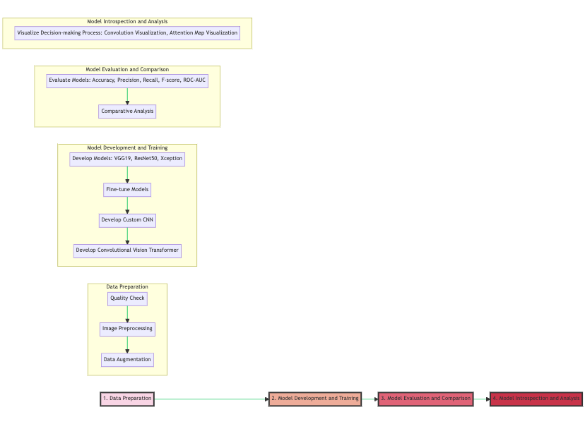**

Figure 1 Methodology diagram.

## ***1. Data Preparation:***

The dataset for this research is sourced from an open-access compilation of chest radiological images online. Categorized into COVID-19, Lung Opacity, Normal, Viral Pneumonia, and Tuberculosis, it offers a broad spectrum for investigation. The dataset's quality is verified, emphasizing frontal view images due to their diagnostic relevance and consistency. All images undergo a label accuracy check, followed by preprocessing to standardize size and format. Data preparation step consists of EDA, image pre-processing and batching, shuffling which are discussed below. Sample images from the training and testing set is given below:

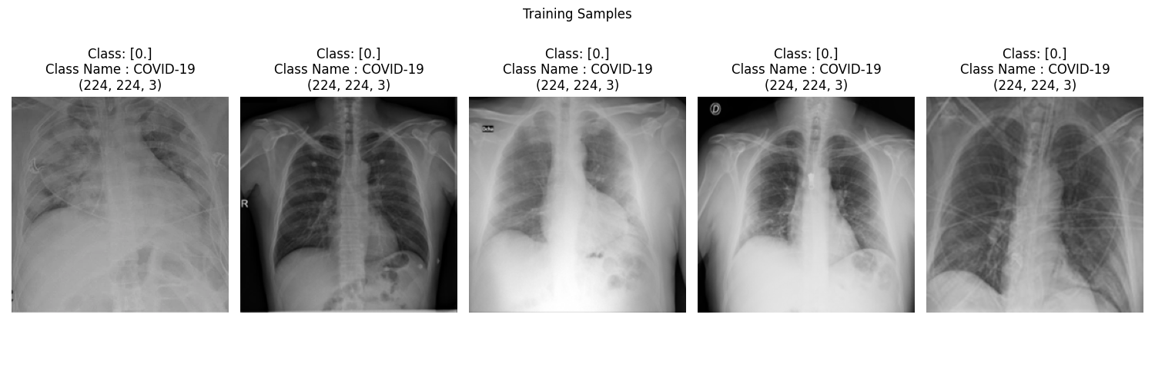

Figure 2 Sample images from the training set.

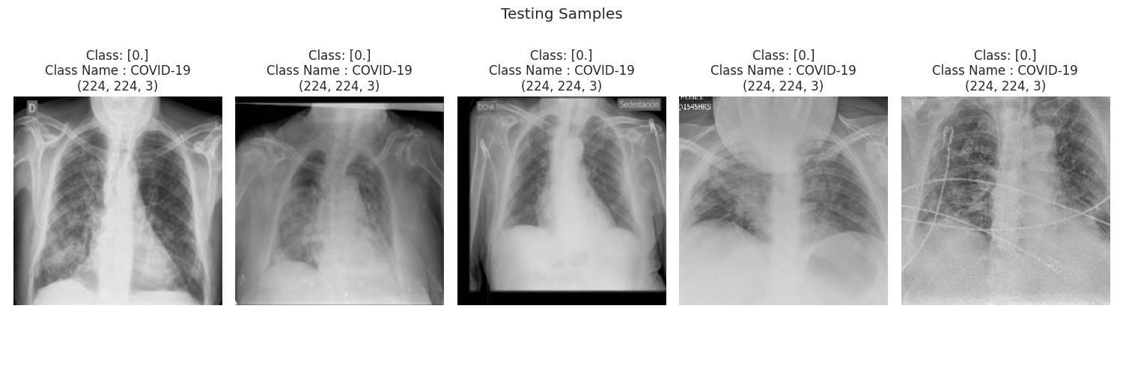

Figure 3 Sample images from the testing set.

### ***Exploratory Data Analysis (EDA):***

#### **Distribution of classes across different datasets.**

**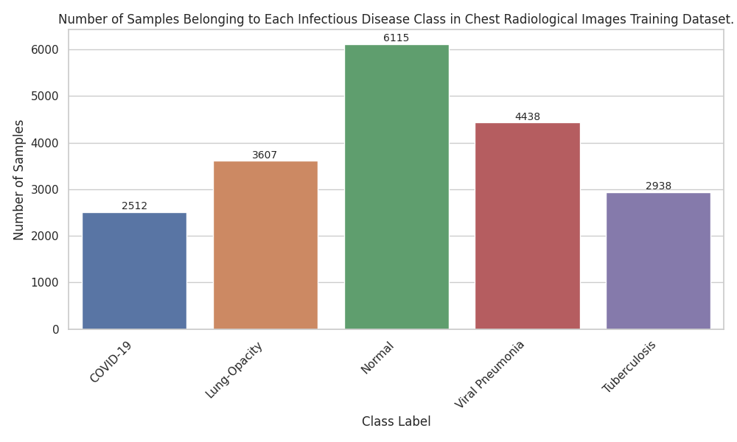**

Figure 4 Class distribution in the training set.

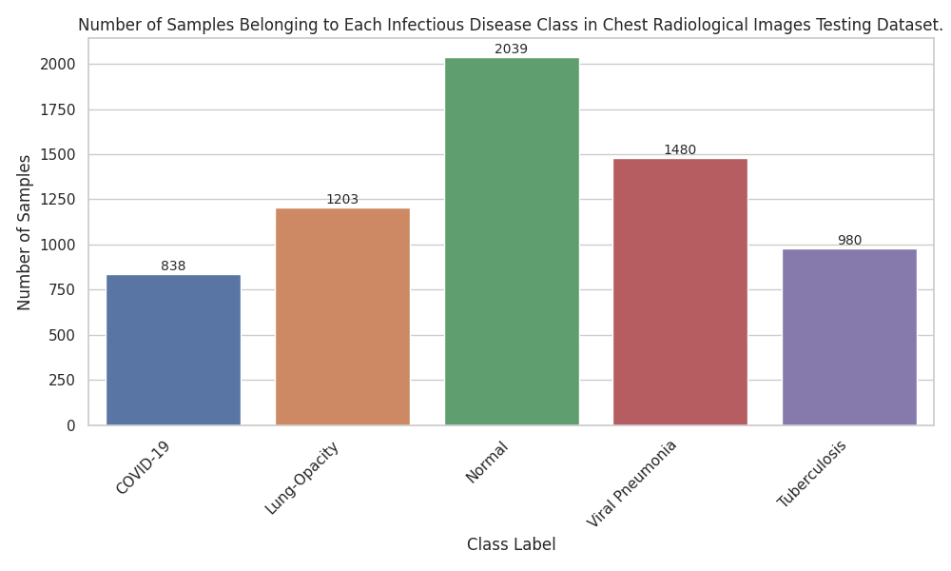

Figure 5 Class distribution in the testing set.

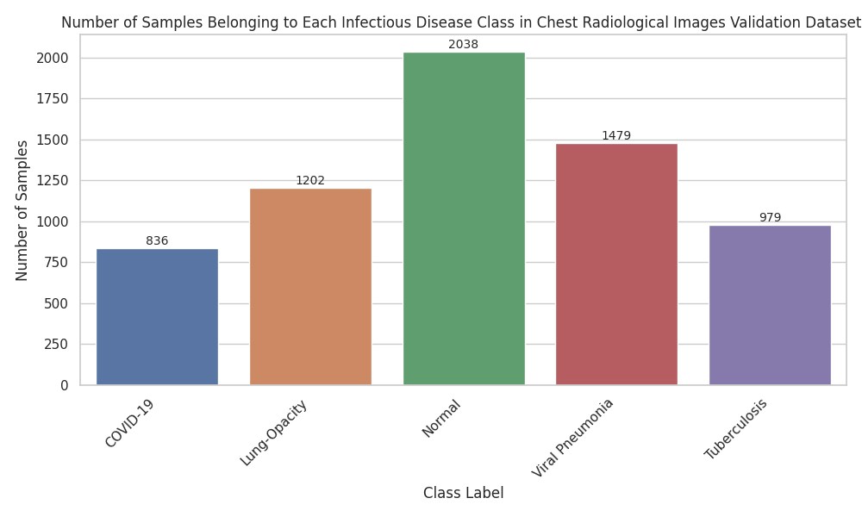

Figure 6 Class distribution in the validation set.

* Upon examining the distribution of classes across training, testing and validation datasets in figure 4,5 and 6, it is evident that there is an imbalance among the classes. The 'normal' category is the most represented, especially in the training set, while the 'covid19' and 'tuberculosis' categories have fewer samples.
* While the training, testing, and validation datasets maintain a similar proportion of classes, the discrepancies in absolute counts can have significant implications in model training and performance evaluation.

**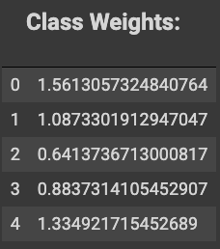**

Figure 7 Global class based weights to use during training.

**Implications of Class Imbalance:**

* Class imbalances can lead to biased model training where the model may exhibit a predisposition towards predicting the majority class (in this case, 'normal'), as the model gets "rewarded" more often for predicting the majority class correctly.
* Models trained on imbalanced data can have misleadingly high accuracy but perform poorly in real-world scenarios, especially when predicting minority classes. Such a model might fail to accurately detect 'covid19', which is particularly concerning given the implications for patient care and public health.

**Justification for using class weights:**

* Class weights are a common mechanism to handle class imbalances. They work by assigning higher weights to under-represented classes and lower weights to over-represented classes. By doing so, they effectively provide a balanced "penalty" during model training, ensuring that errors in predicting minority classes are "penalized" more than errors in predicting majority classes.
* Given the provided class weights, the 'covid19' category, for instance, has the highest weight, which means the model will be more penalized for misclassifying 'covid19' instances as compared to misclassifying 'normal' instances.
* Utilizing these weights can help the model to be more sensitive to the minority classes, improving its generalization capability and its performance on under-represented categories.

#### **Average pixel intensity distribution by dataset.**

Figure 8 Original training images pixel intensity distribution.

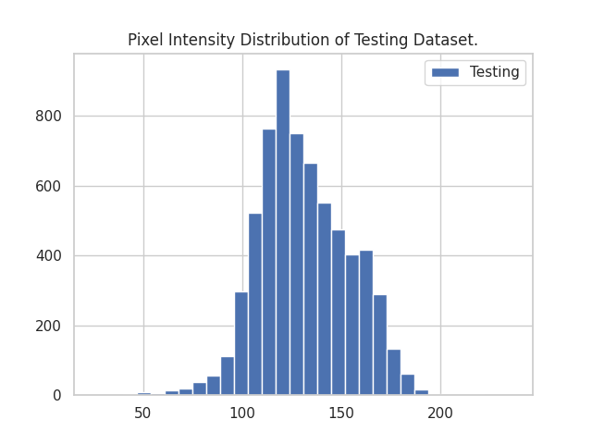

Figure 9 Original Testing Images pixel intensity distribution.

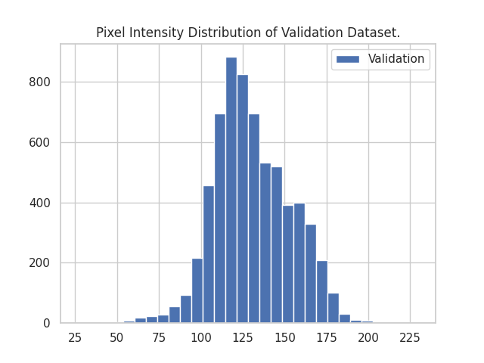

Figure 10 Original Validation Images pixel intensity distribution.

**Uniformity Across Sets:**

The consistency of the pixel intensity distribution across the training, testing, and validation sets as shown in figure 8, 9 and 10 is noteworthy. Such uniformity is indicative of a consistent preparation and acquisition procedure for the radiological images in all datasets. It ensures that the models are trained, validated, and tested under similar image intensity distributions, which is crucial for the generalizability and reliability of the results.

**Central Tendency and Spread:**

The intensity distribution, centered around a mean value of 125, signifies that the majority of the images possess moderate pixel intensities. A mean intensity value around the midpoint of the possible range (50 to 200) suggests a balanced image brightness, possibly resulting from standardization procedures in image acquisition or preprocessing.

**Skewness and Asymmetry:**

The observation that the distribution spikes more steeply from the first quantile to the mean compared to the descent from the mean to the third quantile implies a slight left skewness. This indicates that there are more images with pixel intensities clustering just above the mean than below. Such skewness could be inherent to the nature of the radiological images, possibly due to prevalent imaging artifacts or the inherent contrast characteristics of the diseases in focus.

**Minor Deviations:**

The small spikes observed post the mean intensity can be attributed to specific imaging artifacts, peculiarities in certain image batches, or specific manifestations of the diseases in the chest radiographs. While they represent deviations from the main distribution, their minor nature suggests they might not significantly bias the model. However, understanding the source of these spikes could provide insights into specific subsets of the data or imaging quirks.

**Implications for Modeling:**

A distribution that largely emulates a normal curve, despite minor deviations, ensures that any model trained on this data is not biased due to extreme pixel values. The balance in pixel intensities likely aids in the convergence of model training, as extreme values can sometimes lead to gradient issues.

In summary, the pixel intensity distributions across the datasets offer insights into the consistency and quality of the data. While the distributions are largely normal with a slight skew, understanding the causes behind the minor deviations can further refine the modeling process.

#### **Image pixel intensities distribution by class and dataset.**

**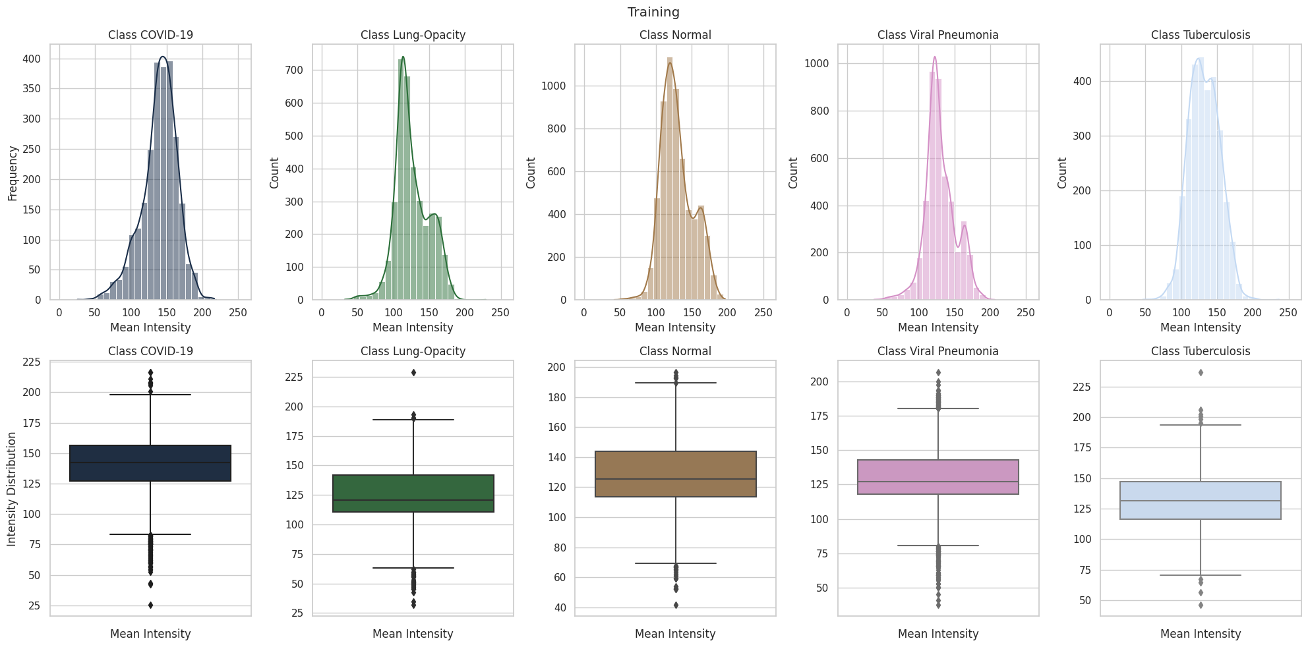**

Figure 11 Training Dataset, Pixel Intensity Distribution by Class.

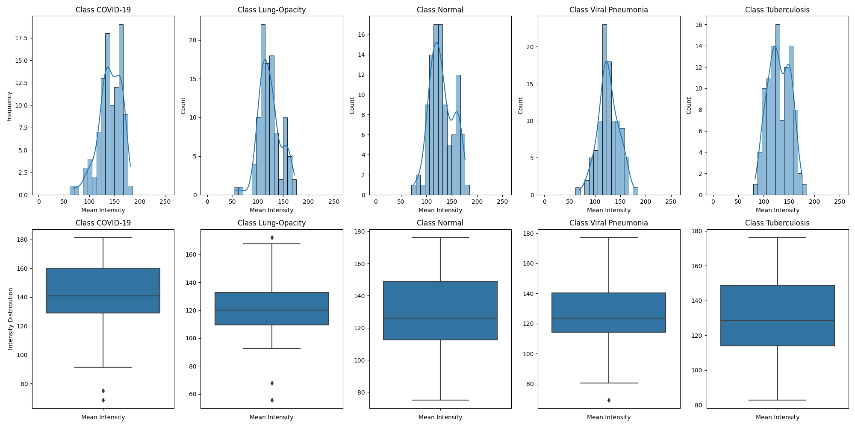

Figure 12 Testing Dataset, Pixel Intensity Distribution by Class.

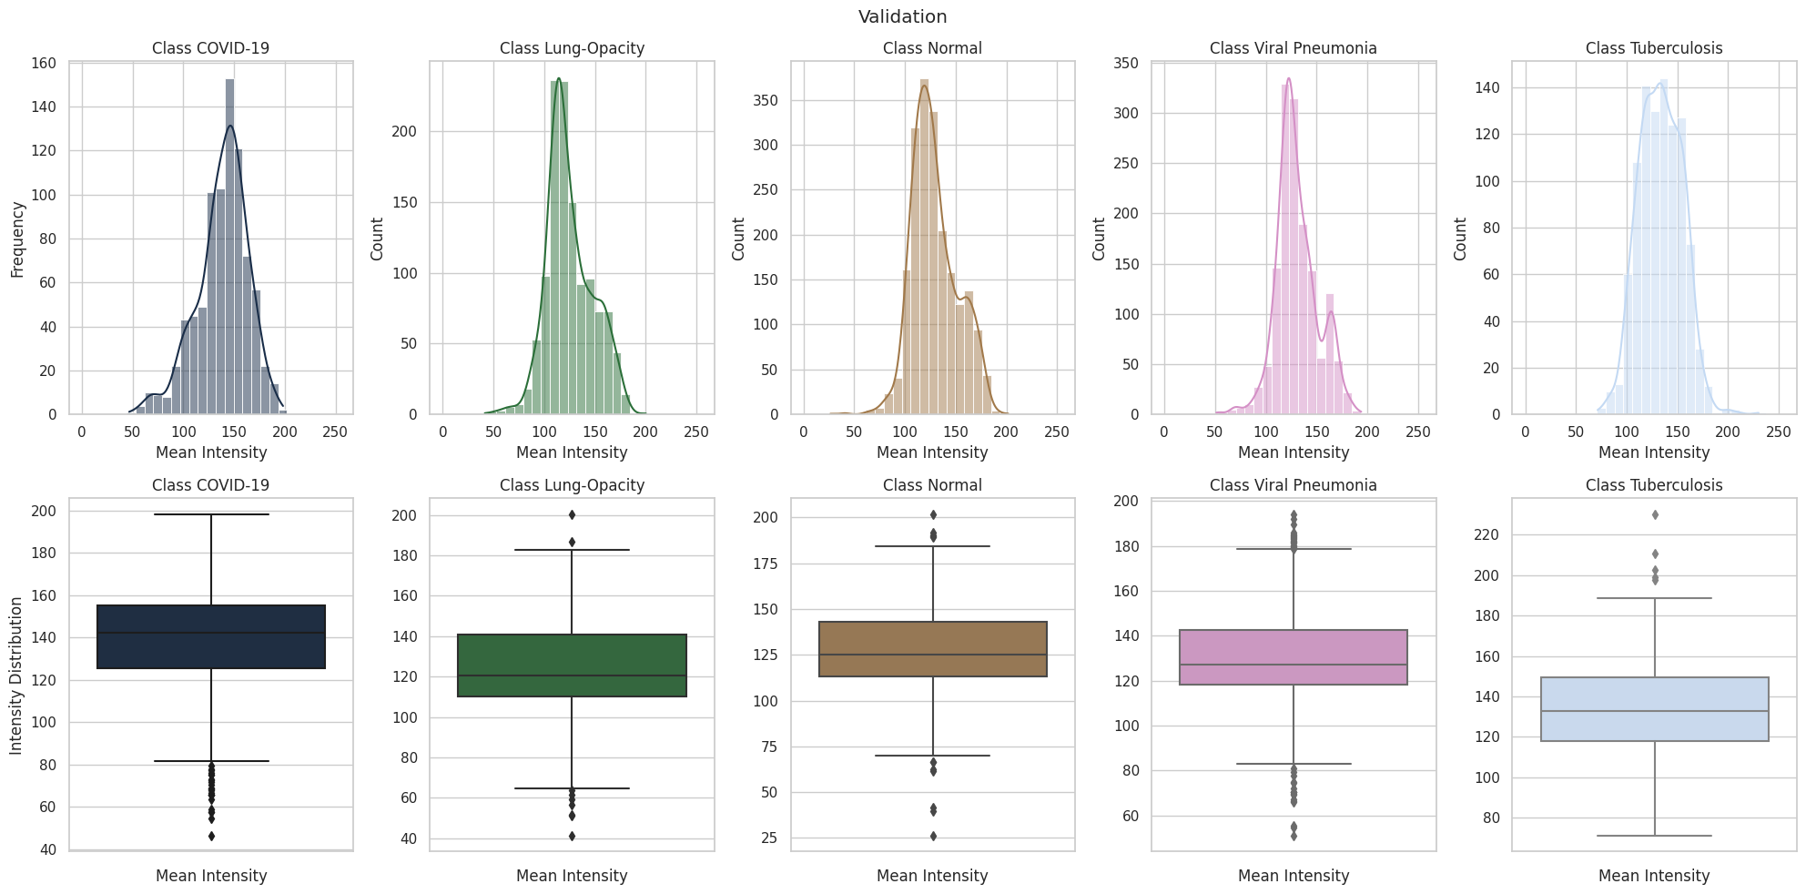

Figure 13 Validation Dataset, Pixel Intensity Distribution by Class.

**Overview of Intensity Distributions:**

The variation in pixel intensity distributions across the different classes as shown by figure 11, 12 and 13 provides critical insights into the distinctiveness of each disease's radiological manifestation. These variations are likely tied to the specific pathophysiological changes associated with each condition.

**Significance of Outliers:**

The presence of outliers in pixel intensities, as revealed by the box plots of figure 11, 12 and 13, could be attributed to specific imaging artifacts, data inconsistencies, or unique case presentations. While outliers can sometimes introduce noise into the model, they can also represent rare but essential data points, warranting careful consideration during preprocessing.

**Potential for Discriminative Modeling:**

The observable differences in the intensity histograms for most classes support the assertion that deep learning models can potentially distinguish between these classes effectively, achieving high performance metrics like accuracy, precision, recall, and AUC.

**Concerns with 'Lung Opacity' and 'Normal' Classes:**

The almost identical pixel intensity distributions of 'Lung Opacity' and 'Normal' classes present a challenge. It suggests inherent similarities in the radiological characteristics of these classes, potentially making it harder for models to differentiate between them. This observation aligns with the anticipation of potentially reduced precision or recall for 'Lung Opacity', emphasizing the need for enhanced feature extraction or specialized modeling techniques to improve differentiation.

**Class-specific Observations:**

* **COVID-19:** A near-normal distribution suggests a balanced representation of this class, perhaps indicating consistent imaging or disease manifestation.
* **Lung Opacity:** The secondary, less frequent peak after the descent from the mean in the intensity distribution could represent a subcategory within the broader class, hinting at multiple radiological patterns associated with this condition.
* **Normal:** Its similarity with 'Lung Opacity' and the secondary peak, though pronounced, signifies potential overlap with pathological conditions.
* **Viral Pneumonia:** The steep ascent and descent with a subsequent spike post-mean could indicate a combination of typical and atypical manifestations of the disease within the dataset.
* **Tuberculosis:** The twin peaks centered around the mean suggest two dominant radiological patterns for this condition, both well-represented in the dataset.

In summary, the distinct pixel intensity distributions across classes hint at the underlying radiological and pathological differences of the conditions. While the dataset promises effective discriminative modeling for most classes, special attention might be needed for the 'Lung Opacity' and 'Normal' classes. Understanding the reasons behind these unique distribution patterns could further inform modeling strategies, ensuring optimized results.

### ***Image Pre-Processing:***

Pre-Processing and Standardization techniques include:

#### **I. CLAHE (Contrast Limited Adaptive Histogram Equalization):**

Figure 14 Experimenting with different clip sizes when applying CLAHE.

CLAHE is a technique that improves the contrast of images. Unlike regular histogram equalization, it enhances contrast in localized regions and can limit the intensification of contrast, thus preventing over-amplification of noise.

**Clip Limit:**

* The clip limit controls the degree to which the histogram is equalized. A low clip limit can result in limited contrast enhancement, while a high clip limit can enhance the contrast too much, making the image look unnatural.
* The experimental range for the clip limit, 0.5 to 2.5, was selected to capture a balanced enhancement as shown in figure 13 above. Sampling random images and applying CLAHE to visualize the effect of different clip limits is a robust empirical approach. It allows for a visual comparison of how different clip limits can enhance or degrade the image quality.
* The choice of a clip limit of 2, as suggested by A. Basu et. al., 2023, aligns with prior research and expert recommendations. At this clip limit, the balance between maintaining natural appearance and achieving desired contrast enhancement is most likely optimized. This is especially crucial in medical images, where over or under-enhancement could obscure critical details.

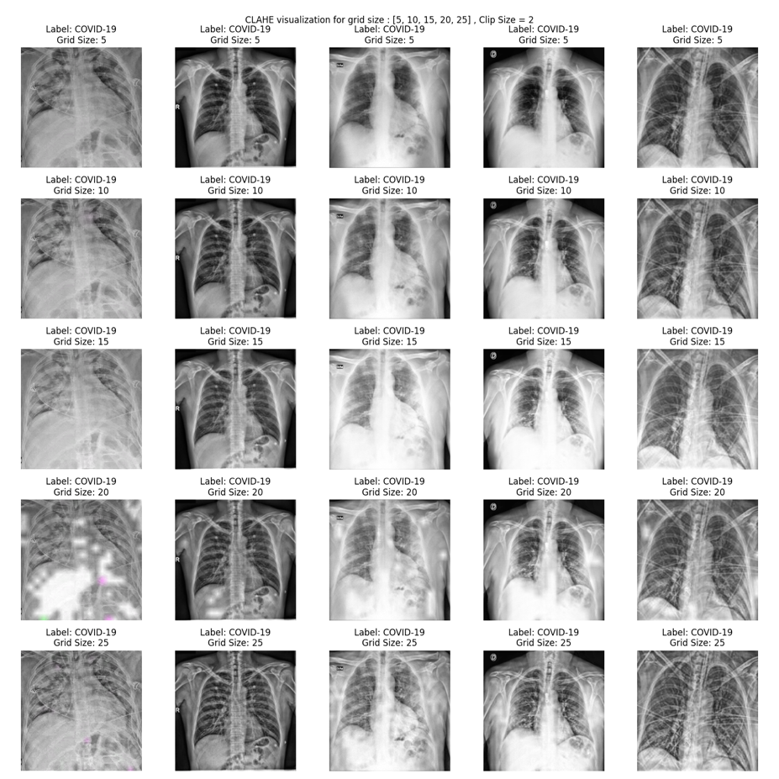

Figure 15 Experimenting with different grid sizes when applying CLAHE.

**Grid Size:**

* The grid size in CLAHE determines the size of the contextual region for localized histogram equalization. Smaller grid sizes can result in a high level of detail enhancement but might also amplify noise. Larger grid sizes can smooth out the contrast enhancement, reducing noise but also potentially obscuring fine details.
* The selected range of 5 to 25 for grid size experimentation as shown in figure 15 above encompasses both fine and broader contextual regions. By conducting a similar empirical evaluation as with the clip limit, it is ensured that the selected grid size resonates with the dataset's specific characteristics.
* Settling on a grid size of 15 is a logical choice given that it offers a mid-level granularity. This size is likely large enough to prevent excessive noise amplification yet small enough to retain critical details in the radiological images.

In conclusion, the selected parameters for CLAHE, both the clip limit of 2 and the grid size of 15, appear to be optimized for the specific characteristics of the dataset. The empirical approach of visual evaluation supplemented by literature recommendations ensures that the pre-processing maintains the integrity and clarity of the original radiological images.

#### **II. Zoom: Evaluating and justifying zoom factor selection.**

#### 

Figure 16 Experimenting with different zoom factors.

Zooming, as a pre-processing technique, offers a two-fold benefit when applied to chest X-ray images:

1. **Artifact and Noise Elimination:** Different healthcare facilities and equipment manufacturers often place labels, brandings, or other diagnostic details directly on radiological images. These markings, which are typically concentrated around the image's periphery, are essentially "noise" for deep learning models. Such noise, if not addressed, can introduce unwanted variances and biases into the dataset. By zooming into the core region of the chest X-ray, we can effectively remove or reduce these extraneous details, focusing the model's attention on the medically relevant portions of the image.
2. **Avoiding Misleading Model Training:** A model's success should come from its ability to recognize and differentiate pathology from normalcy based on medically relevant features, not from irrelevant artifacts. A known pitfall in deep learning, particularly in the medical domain, is that models might sometimes leverage these artifacts or noise for predictions. Such a phenomenon could lead the model to make accurate predictions for the wrong reasons, thereby reducing its generalizability and reliability. By zooming in and eliminating these potential pitfalls, we are ensuring that our model is truly learning from the underlying pathology and not from irrelevant visual cues.

The zoom factor as shown in figure 16, determines the degree to which we are magnifying or focusing on the central portion of the radiological image. It's pivotal to strike the right balance: too much zoom might result in loss of essential medical details, while too little zoom might not effectively eliminate the artifacts and noise around the edges.

**The Rationale for Varying Zoom Factors:**

**1:** Represents the original image without any zoom. Using this retains all artifacts and potential noise.

**0.85 to 0.75:** These values represent varying degrees of zooming. As the factor decreases, the image becomes more zoomed in, cropping out more of the image's periphery. This range was chosen to understand the implications of slight to moderate zooms on the dataset.

**Selection of 0.83 as the Optimal Factor:**

Through experimentation, it was observed that a zoom factor of 0.83 effectively reduced the unnecessary details and noise around the borders of the X-ray images without compromising the medically relevant regions.

Factors closer to 1 (like 0.85) might not have adequately removed all peripheral artifacts. On the other hand, more aggressive zoom factors, such as 0.75, risked omitting vital areas of the lungs or other important structures, which could be crucial for accurate diagnosis and model training.

In conclusion, the selection of a 0.83 zoom factor was a well-considered decision, aimed at preserving the integrity of medical details while removing potential distractors. This careful calibration ensures that the model gets a clear, focused view of the essential features without being side-tracked by external noise or losing out on important information.

#### **III. Image Sharpening: Evaluating and justifying kernel selection.**

#### 

Figure 17 Experimenting with different image sharpening kernels.

In the realm of medical imaging, ensuring clarity and precision is pivotal. Image sharpening serves as an essential technique to enhance boundaries and delineate intricate structures, vital for accurate diagnosis and analysis. In this endeavor, we evaluated multiple sharpening kernels to determine their efficacy on the given dataset as shown in figure 17.

1. **Basic Sharpening Kernel:**
   * **Structure:** The kernel essentially aims to accentuate the central pixel by bolstering its intensity relative to its neighboring pixels.
   * **Outcome:** This kernel provided a balanced enhancement to the images, elevating the clarity without introducing excessive noise or artifacts. The contrast adjustments appeared homogeneous, ensuring the visibility of crucial structures remained intact.
2. **Laplacian Sharpening Kernel:**
   * **Structure:** This kernel is designed to highlight rapid changes in pixel intensity, emphasizing boundaries and edges.
   * **Outcome:** The Laplacian kernel, while renowned for its edge detection, turned out to be excessively aggressive for our dataset. The blacked-out images suggest an overemphasis on the high-frequency components, overshadowing crucial image details.
3. **Diagonal Edge Sharpening:**
   * **Structure:** Primarily targets diagonal edges, attempting to augment them.
   * **Outcome:** The resultant entirely white images indicate an overamplification of these diagonal edges, leading to a loss of critical contextual information.
4. **Exaggerated Sharpening:**
   * **Structure:** As the nomenclature suggests, this kernel intensifies image structures aggressively.
   * **Outcome:** The produced images were riddled with noise, suggesting that even minor imperfections were disproportionately amplified, obfuscating key image details.
5. **Another Variant of Laplacian:**
   * **Structure:** A different take on the standard Laplacian, still focusing on sudden intensity shifts.
   * **Outcome:** The images seemed too ethereal, with a "jelly-like" transparency, implying that the kernel might not resonate well with the intrinsic characteristics of our dataset.

**Decision Rationale:** Given the outcomes, the Basic Sharpening Kernel emerged as the most suitable candidate. The reasons are multifold:

* **Balanced Enhancement:** Unlike other kernels, the Basic Sharpening Kernel managed to improve clarity without distorting the core structures or introducing unwanted artifacts.
* **Retention of Medically Relevant Information:** In the medical domain, the fidelity of data is paramount. This kernel retained essential information, ensuring that medical professionals can glean accurate insights.
* **Consistency with Literature:** Often, the simpler approaches, backed by a long-standing history of application, can outperform more complex ones, especially when the dataset's characteristics are attuned to such methods.

The empirical evaluation underscores the significance of methodical kernel selection in image sharpening. While more intricate kernels may promise superior results, the Basic Sharpening Kernel's efficacy on our dataset reiterates the notion that simplicity, when aligned with the data's nature, can yield optimal outcomes. The chosen kernel promises enhanced image clarity, ensuring accurate and effective medical analyses.

#### **IV. CLAHE + Image Sharpening**

**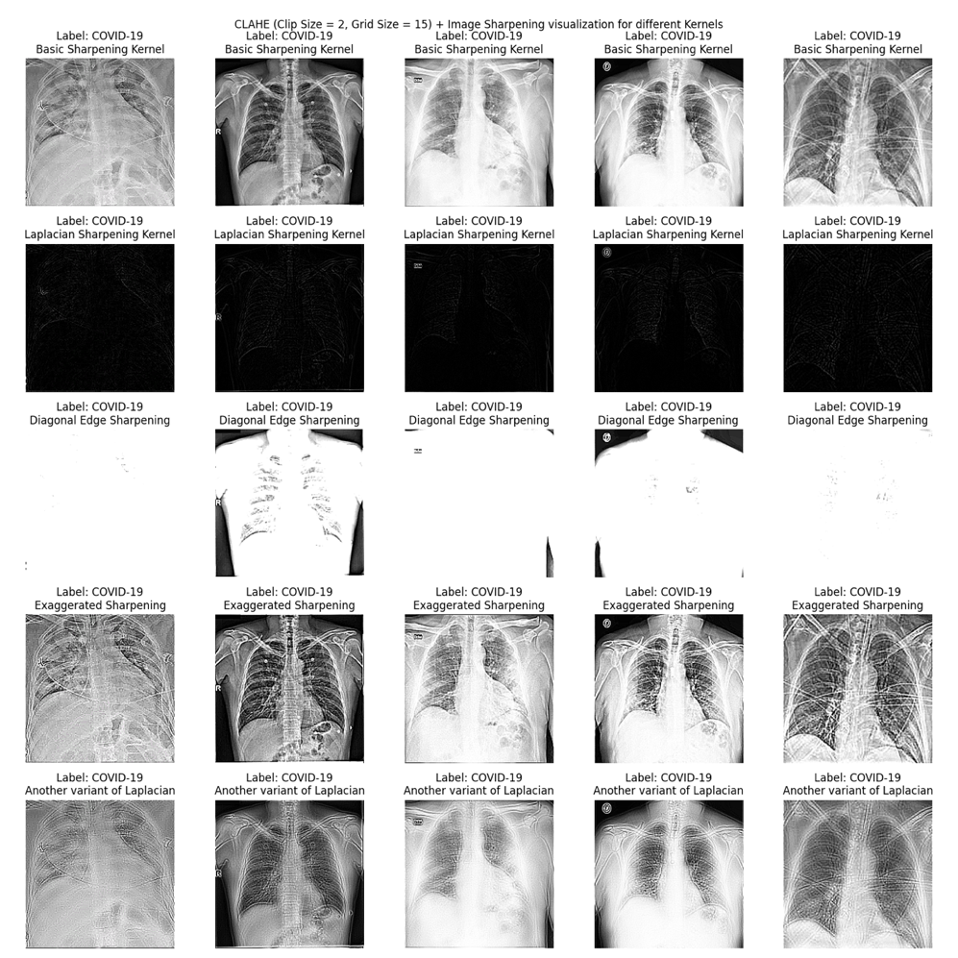**

Figure 18 Experimenting with different image sharpening kernels when applied to CLAHE processed Images.

In this experiment, the efficacy of various image sharpening kernels was assessed post the application of CLAHE (Contrast Limited Adaptive Histogram Equalization).

**Procedure:** Five images were selected as a representative sample and underwent CLAHE processing, employing a clip limit of 2 and a grid size of 15. Subsequent to the CLAHE application, the different sharpening kernels, previously delineated, were applied to these images.

**Findings:** The results mirrored those observed in the standalone sharpening kernel evaluation:

1. **Basic Sharpening Kernel:** Once again, it proved to be the most efficacious. Its judicious amplification of edge details complemented the enhanced contrast brought about by CLAHE, yielding images that were crisp, clear, and retained critical medical details.
2. **Laplacian Sharpening Kernel:** Even post-CLAHE, the Laplacian method's aggressive edge enhancement produced images that were predominantly blacked out. It indicates that the kernel's nature remained incompatible with the dataset's characteristics, despite the contrast enhancements of CLAHE.
3. **Diagonal Edge Sharpening:** The CLAHE pre-processing did little to alter the outcome of this kernel. The resultant images remained overwhelmingly white, signifying an overemphasis of diagonal components.
4. **Exaggerated Sharpening:** The images continued to exhibit pronounced noise. This suggests that the kernel's aggressive amplification didn't resonate with the dataset, irrespective of CLAHE application.
5. **Another Variant of Laplacian:** The ethereal, 'jelly-like' transparency persisted, revealing that the kernel's adjustments weren't harmonious with the inherent details of the radiological images.

The congruence in results from both standalone and combined evaluations emphasizes the robustness of the findings. The Basic Sharpening Kernel's performance consistency, both pre and post-CLAHE, underscores its adaptability and suitability for this dataset. By pairing it with CLAHE's strengths in contrast enhancement, we harness a potent synergy, yielding images of high clarity and detail, crucial for reliable medical interpretations.

When combining techniques like CLAHE and image sharpening, the overarching goal remains: achieving clearer, more detailed images without compromising the original information. This experiment reinforces the importance of judicious technique selection, ensuring that combined methodologies bolster, rather than hinder, the desired outcomes.

#### **V. ZOOM + CLAHE + Image sharpening with basic sharpening kernel**

**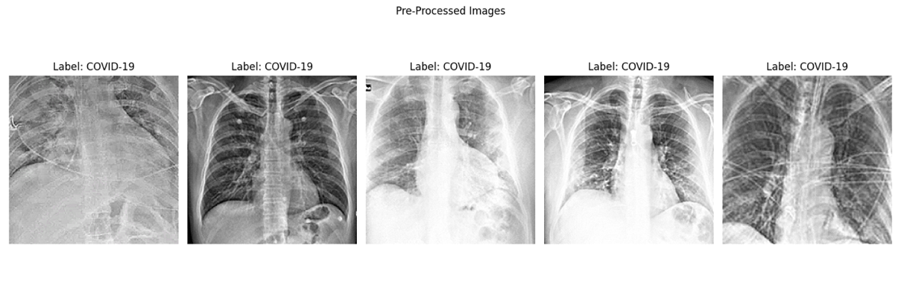**

Figure 19 Transforming images with Zoom, CLAHE and Image Sharpening.

In this section, a systematic combination of the previously discussed, three fundamental techniques were employed on a selected batch of images to evaluate the compounded effects and the potential synergy that could be realized as shown in figure 19.

Five representative images, as shown in figure 19, from the dataset were chosen as a sample for this integrated evaluation. The selected images underwent:

1. **Zoom** **with a factor of 0.83**: This initial step aimed to crop out potential artifacts and noise that often reside along the image periphery. Given the variability in radiological image presentations from different sources, this was a vital step in standardizing the primary region of interest.
2. **CLAHE** **with a clip limit of 2 and grid size of 15**: Post zooming, the images were subjected to Contrast Limited Adaptive Histogram Equalization. This is a powerful method for contrast enhancement, especially effective for images like X-rays which may have large regions of dark background. The chosen parameters, informed by prior experimentation, ensured optimized contrast while maintaining genuine image features.
3. **Basic Sharpening Kernel**: The final step was to sharpen the images to accentuate the edges and finer details. The chosen kernel, as established from previous assessments, delivered optimal sharpening without introducing undue noise or artifacts.

Upon visualization, several observations were noted:

* The zooming process effectively trimmed any extraneous details and potential noise, offering a more focused view of the primary chest region.
* CLAHE transformed the images to have a more uniform and pronounced contrast, making finer details more discernible.
* The application of the Basic Sharpening Kernel post-CLAHE further enhanced the edges and contours, making structures within the chest region distinctly clear.

The integrated approach of Zoom, CLAHE, and Image Sharpening presented a coherent and effective strategy for image pre-processing in the context of chest radiological images. Each step complemented the other, ensuring that the final transformed image retained its medical integrity while enhancing features critical for detailed examination. Such a methodical and sequential application of image processing techniques not only maximizes the visual quality but also ensures the preservation of crucial medical details.

#### **VI. Rescaling: Visualizing the average pixel intensity distributions of the original image, pre-processed image (zoom+clahe+sharpening), rescaled images.**

The assessment of pixel intensity distributions is an essential component of the image preprocessing pipeline. Effective modifications to these distributions, particularly through techniques such as rescaling, can potentially improve the robustness and accuracy of machine learning models, especially in the context of deep learning with pre-trained networks. In the ensuing sections, we critically evaluate the transformations in pixel intensity distributions across different stages of preprocessing.

**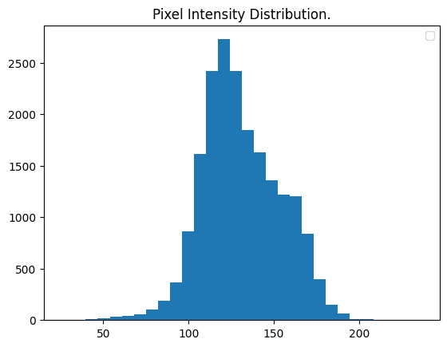**

Figure 20 Average pixel intensity distribution of the original training Images.

**Original Image**:

* **Pixel Intensity Range**: 50 to 200
* **Mean Intensity**: 125

In the unprocessed state, the images present a somewhat narrow spectrum of pixel intensities as shown in figure 20. A centralized mean suggests a moderate brightness level, common to radiological images without any enhancement. Here, the concern could be that any model trained on such data might miss nuanced details, especially if those details lie in shadowed or overly bright regions.

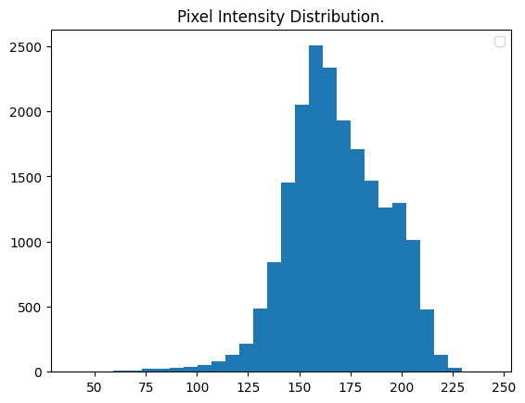

Figure 21 Average pixel intensity distribution of the training dataset post processing (Clahe + Image sharpening + zoom) but pre rescaling.

**After ZOOM + CLAHE + Sharpening**:

* **Pixel Intensity Range**: 50 to 250
* **Mean Intensity**: 160

Post the application of zoom, CLAHE, and sharpening, the images undergo a discernible transformation in their intensity distribution as shown in figure 21 when contrasted with figure 20. The extended upper bound of intensity indicates a more comprehensive portrayal of contrasts, highlighting the efficacy of CLAHE in enhancing localized contrasts. The shift in mean to 160 signifies a brighter overall image. This broadened spectrum is beneficial as it could potentially unmask subtler details and enhance the image's diagnostic value.

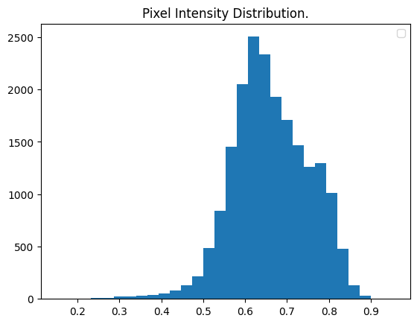

Figure 22 Average pixel intensity distribution post processing , post rescaling of training images.

**After Rescaling**:

* **Pixel Intensity Range**: 0 to 9
* **Mean Intensity**: 0.65

Rescaling serves a dual purpose: to standardize pixel intensities for a consistent dataset and to prepare the dataset for certain machine learning algorithms. The narrowed range post-rescaling is a normalization strategy, ensuring every image in the dataset shares a common scale. Though the mean intensity drops considerably, the critical aspect is maintaining the relative contrast and details of the image as shown in figure 22.

**Implications of Rescaling for Deep Learning and Pre-trained Networks**:

1. **Enhanced Model Convergence**: Neural networks converge faster on normalized data. When input data features have similar scales, gradient descent algorithms require fewer iterations to minimize the loss function. Given the iterative nature of these algorithms, even minor improvements in convergence rates can significantly expedite training.
2. **Optimal Utilization of Pre-trained Models**: Many pre-trained deep learning models expect input images to have a specific pixel intensity range, often between 0 and 1, or -1 and 1. Rescaling ensures compatibility with these models, allowing researchers to leverage the power of transfer learning effectively.
3. **Mitigating Overfitting**: When working with high-resolution medical images, models can sometimes learn noise or unwanted details, leading to overfitting. Rescaling, by standardizing the pixel intensities, can act as a form of regularization, helping the model to focus on the most vital features.

Through a holistic evaluation of the average pixel intensity transformations, it's evident that each preprocessing step offers its own set of benefits, shaping the data for optimal analysis. Rescaling, as the final step, plays an indispensable role in ensuring that the images are primed for deep learning, especially when leveraging the capabilities of pre-trained networks.

#### **VII. Zero Centering and its significance.**

Zero centering, also known as mean subtraction, is a crucial step in the image preprocessing pipeline, especially in the realm of deep learning. By adjusting the pixel values such that the mean of the data becomes zero, we introduce several computational and optimization advantages. When evaluating the average pixel intensity distribution of figure 23 generated on the rescaled and post processed training images, the subsequent mean of 0 with pixel values spanning from -0.5 to 0.5 indicates that zero centering has been effectively implemented.

**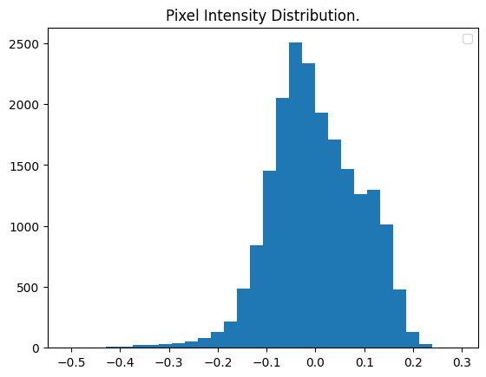**

Figure 23 Average pixel intensity distribution of training images post zero centering.

**The importance of zero centering in the context of deep learning and pre-trained models:**

1. **Improved Optimization**: Neural networks, particularly deep architectures, use gradient-based optimization techniques such as Gradient Descent. Zero centered data can make these gradients more consistent, leading to a more stable convergence. In simpler terms, if the data isn't centered, the gradients may oscillate and take longer paths towards the minima, delaying convergence.
2. **Mitigates Internal Covariate Shift**: When training deep networks, the distribution of activations changes during the training process, a phenomenon known as internal covariate shift. This shift can slow down the training process as each layer must adapt to a new distribution in every training round. Zero centering, in combination with normalization techniques like Batch Normalization, can reduce this shift, leading to faster training.
3. **Enhanced Generalization**: Zero centering can also act as a form of regularization. By ensuring that the input features (in this case, pixel values) are on a similar scale and centered around zero, we mitigate the risk of certain weights becoming overly dominant, which can result in overfitting.
4. **Compatibility with Pre-trained Models**: Much like rescaling, many pre-trained models expect input data to be zero-centered. These models, trained on vast datasets, have weights optimized for zero-centered data. Introducing data with a different distribution might not harness the full potential of these pre-trained models, leading to sub-optimal performance.
5. **Neuron Activation Symmetry**: Activation functions in neural networks, like the hyperbolic tangent (tanh) function, are symmetric around zero. When data is zero centered, these activations can operate in their most sensitive region (where the gradient is steeper), ensuring that the backpropagation process has well-scaled, non-saturated gradients.

Zero centering, while seemingly a straightforward adjustment, plays a pivotal role in enhancing the efficiency and performance of deep learning models. Especially when leveraging pre-trained models, this preprocessing step ensures that the foundational structures and optimizations inherent to these models are effectively utilized. The overarching goal is to provide the neural network with data that is amenable to learning, and zero centering contributes substantially towards achieving that.

### ***Shuffling and Batching:***

The initial dataset was provided in **.npz** format. While **.npz** format is versatile for storing arrays, it has the potential drawback of being memory-intensive, particularly when dealing with large datasets such as radiological images. Consequently, this can make data manipulation and processing challenging, especially on systems with constrained RAM.

To mitigate these computational constraints, the dataset underwent serialization with a pixel intensity data type (**dtype**) conversion to **float32**. The choice of **float32** was strategic: it strikes a balance between precision and memory consumption, ensuring that the images retain enough detail for accurate analysis while consuming less memory.

Following this, the serialized data was saved in **hdf5** format. The **hdf5** format is specifically designed for storing and organizing large volumes of data. It facilitates efficient data access without needing to load the entire dataset into memory, making it more computationally efficient than the **.npz** format for this particular application.

After obtaining the data in **hdf5** format, TensorFlow's **tf.data.Dataset** API was employed to further enhance the data handling process. By leveraging the **MapDataset** and **PrefetchDataset** variants from **tf.data.Dataset**, the data pipeline operations were made even smoother. Specifically:

**MapDataset**: Enables on-the-fly data transformations, like preprocessing, in a manner that's both efficient and parallelized. For instance, preprocessing operations using the map function are executed effectively.

**PrefetchDataset**: Allows the model training step to overlap with data fetching. This means while the model is being trained on a batch of data, the next batch is simultaneously being prepared, leading to reduced GPU idle time and improved training speeds.

A batch size of 128 is used. The dataset is batched and shuffled. Shuffling is a crucial step in many machine learning workflows, and when combined with the features of TensorFlow's **tf.data.Dataset** API, especially the **PrefetchDataset**, it becomes even more significant.

***Importance of Shuffling in Machine Learning:***

**Minimize Overfitting:** When training a model, especially deep learning models, there's always a risk of overfitting if the data presented to the model is in a specific order. By shuffling the dataset, the randomness ensures that the model doesn't learn specific patterns from the sequence in which the data is presented.

**Uniform Distribution:** In a dataset, there might be patterns or sequences. For instance, a dataset could have been sorted or recorded in a specific manner (e.g., all COVID-19 images first, followed by Tuberculosis). Shuffling breaks any such inherent sequence, ensuring that during training, the model gets a mix of all classes and is not biased due to the order of data.

***Combining Shuffling with tf.data.Dataset PrefetchDataset:***

When using **tf.data.Dataset**, particularly **PrefetchDataset**, shuffling is vital for a couple of reasons:

**Efficiency with Random Access:** **PrefetchDataset** allows the model training process to overlap with data fetching. If the data is shuffled, this means each fetched batch (while the current one is being processed) is a random subset, reducing the chances of repetitive patterns and ensuring a diverse mix of data in every batch.

**Generalization across Epochs:** When training across multiple epochs, without shuffling, the model would see the same sequence of batches in every epoch. This can potentially cause the model to memorize patterns, leading to poor generalization. By shuffling the dataset for each epoch, every pass the model makes over the data is slightly different, leading to a better-trained, more generalized model.

In conclusion, shuffling, when combined with the asynchronous data fetching capabilities of **PrefetchDataset**, ensures a smooth, randomized data pipeline. This not only aids in model generalization but also utilizes computational resources efficiently by avoiding any repetitive patterns during the training process.

Below Class distribution of the batches of the training set is given:

**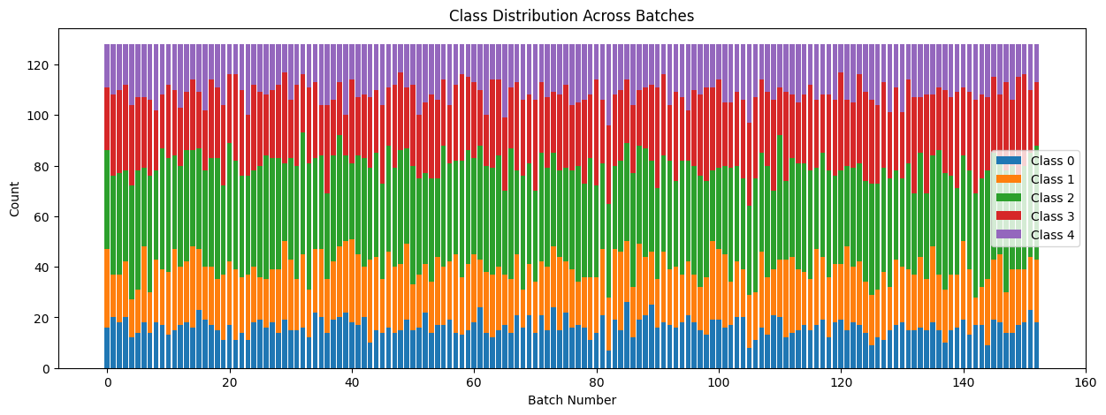**

Figure 24 Class distribution across batches of the training set.

## ***2. Model Development and Training:***

Various deep learning models, including architectures like VGG19 and ResNet50, are fine-tuned on the curated dataset. Hyperparameters are adjusted to enhance performance.

* A proprietary CNN is formulated utilizing depthwise separable convolution layers, dilated convolution layers, residual blocks, spatial attention and batch normalization.
* A specialized Convolutional Vision Transformer model is developed based on vit-B16 (Dosovitskiy et. al., 2020), integrating transformer capabilities, notably the self-attention mechanism, for image classification.
* **Training Protocol:** The pre-trained models are trained using a dedicated training set while a validation set aids in parameter tuning. The Adam optimizer is employed to minimize the categorical cross entropy loss function. Transfer learning is invoked by leveraging pre-trained architectures like VGG19 and ResNet50. Initially, the models' tops serve as feature extractors. Once the gradients adjust, the entire network undergoes training. This two-phase protocol is pivotal, ensuring preliminary model adaptation followed by comprehensive training.

## ***3. Model Evaluation and Comparison:***

Post-training, models are evaluated on a separate test set. Metrics like accuracy, precision, recall, F-score, and ROC-AUC offer a holistic performance view. A comparative analysis will be conducted to determine the most effective model.

**Accuracy**:

* **Definition**: It is the ratio of correctly predicted instances to the total instances. ***Accuracy=Number of correct predictions / Total number of predictions made***

**Precision**:

* **Definition**: It is the ratio of correctly predicted positive observations to the total predicted positives.

***Precision= True Positives / (True Positives + False Positives)***

***Recall (Sensitivity or True Positive Rate):***

* **Definition***: It is the ratio of correctly predicted positive observations to all the actual positives****.***

***Recall=True Positives / (True Positives + False Negatives)***

**F-score (F1 Score)**:

* **Definition**: The F1 Score is the weighted average of precision and recall. It takes both false positives and false negatives into account.

***F1 Score=2×(Precision×Recall) / (Precision + Recall)***

**ROC-AUC (Receiver Operating Characteristic - Area Under the Curve)**:

* **Definition**: ROC is a probability curve, and AUC represents the degree or measure of separability. The ROC curve plots the true positive rate (recall) against the false positive rate at various threshold settings. The AUC quantifies the overall ability of the model to discriminate between positive and negative classes.

## ***4. Model Introspection and Analysis:***

Understanding how deep learning models make decisions is crucial, especially in the medical field, where interpretability can be the bridge between artificial intelligence and clinical adoption. Visualization tools aid in demystifying the intricate operations within models.

1. **Grad-CAM (Gradient-weighted Class Activation Mapping)**:
   * Grad-CAM leverages the gradients of any target concept entering the model's final convolutional layer to produce a coarse localization map. This map emphasizes the important regions in the image for predicting a specific concept (Selvaraju et al., 2017).
   * This technique is especially beneficial in medical imaging as it highlights the regions that the model considers most significant when making a prediction. For example, in radiology images, it can identify areas of concern that lead to a particular diagnosis, making it easier for medical professionals to understand and trust the model's decision.
2. **Guided Grad-CAM**:
   * This method is a combination of guided backpropagation and Grad-CAM, offering high-resolution visual explanations for the decisions made by the model (Selvaraju et al., 2017).
   * The enhanced resolution of Guided Grad-CAM can reveal intricate details in radiological images, allowing a granular understanding of which image features influence the model's decisions.
3. **Spatial Attention Layers Visualization**:
   * Spatial attention mechanisms within CNNs concentrate on specific input image regions, bestowing higher significance on certain zones (Woo et al., 2018).
   * Visualizing spatial attention can provide insights into regions of the image the model deems significant. In medical imaging, this can correlate with areas of disease manifestation or other abnormalities, reinforcing the model's decisions with visual evidence.
4. **Multi-head Self-attention Visualization in Vision Transformers**:
   * VisionTransformers (ViTs) employ self-attention mechanisms to determine the relative importance of distinct parts of an image. The multi-head attention facilitates this process in multiple pathways, capturing various image relationships (Dosovitskiy et al., 2020).
   * By visualizing these attention weights, one can gain insights into which parts of an image the model views as interrelated or crucial for a given prediction. In a medical context, this can reveal not just areas of concern, but also how different areas of an image might collectively influence a diagnosis.

# ***Results and Discussion:***

The primary objective of this study is to thoroughly assess various deep learning models concerning their capacity to categorize distinct conditions based on chest radiology images. The models' performance is gauged through a broad spectrum of metrics - from loss to the nuanced AUC curves. Besides numerical metrics, visualization techniques further offer insight into models' focal points when making a prediction.

Prior to diving into individual model evaluations, it's pertinent to understand the common framework underpinning their training:

1. **Models Under Evaluation**: This study critically analyzes four architectures:
   * VGG19
   * ResNet50 (both transfer learning and fine-tuning approaches)
   * A custom CNN leveraging depthwise separable convolutions and spatial attention skip connections
   * Vision Transformer (ViT-b16)
2. **Training Dynamics**:
   * Batch size: 128
   * Initial Learning Rate: 0.0001
   * Optimizer: Adam
   * Loss Function: Cross-entropy
   * Activation: Softmax (Post one-hot encoding)

## **I. VGG19 Model Assessment.**

VGG19, a convolutional neural network architecture from the Visual Geometry Group, University of Oxford, is widely regarded for its simplicity and performance in image classification tasks. Predicated on the philosophy of increasing depth via very small (3x3) convolution filters, it holds significance in the landscape of deep learning. This assessment sheds light on its performance for our specific dataset across various training phases.

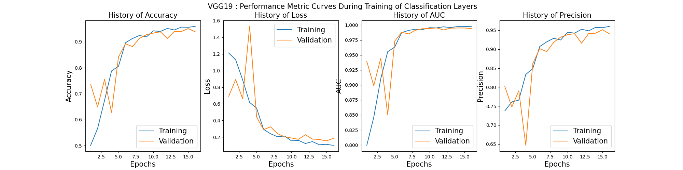

Figure 25 Vgg19 loss accuracy curve during transfer learning.

***Transfer Learning Phase***: During this phase as shown in figure 25, a decline in loss for both training and validation sets was evident. Metrics like accuracy, precision, and recall exhibited an uptick, indicating the model's improving capability to classify images correctly.

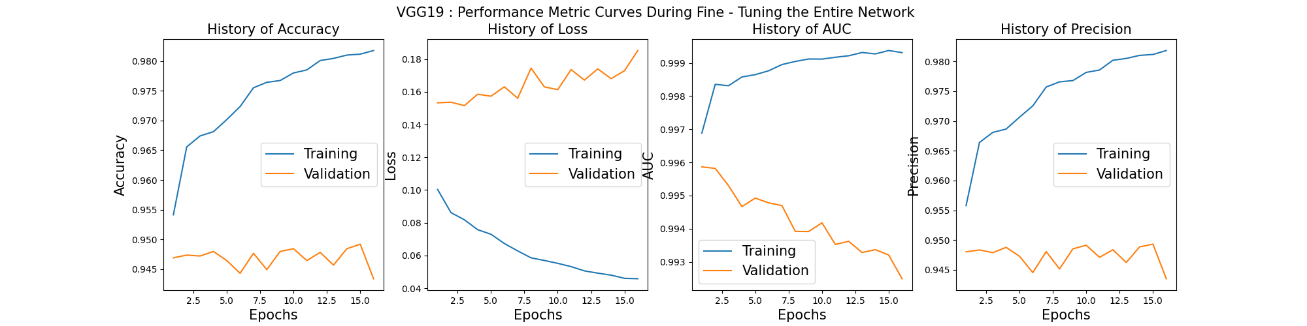

Figure 26 VGG19 loss accuracy curve during fine-tuning.

***Fine-Tuning Phase:*** However, during fine-tuning as shown in figure 26, the model showcased signs of overfitting. While training set metrics flourished, there was a noticeable dip in validation performance, particularly in terms of loss, accuracy, precision, and recall.

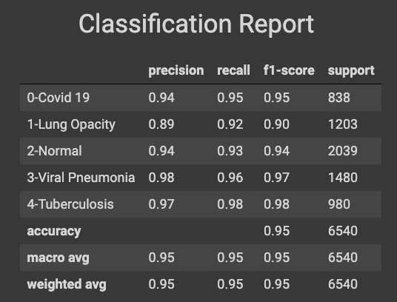

Figure 27 Vgg19 Classification Report.

***Classification Report Analysis:*** For the individual classes as shown in figure 27 above:

* Viral Pneumonia and Tuberculosis classes showcased impressive precision and recall values, suggesting the model's strong capability to detect and correctly classify these conditions.
* Lung opacity and normal images, however, pose a unique challenge. As hinted in our exploratory data analysis, these classes exhibited similar pixel intensity distributions, making them harder to distinguish. This phenomenon was reflected in their precision and recall values. While the values were commendable, they were slightly lower than the other classes, underscoring the inherent challenge in differentiating between these two categories.
* Covid 19 classes also showcased impressive precision and recall but not to the extent of Viral Pneumonia or Tuberculosis. This could largely be attributed to the similarities of the chest X-ray or chest radiology images of covid 19 to that of lung opacity or normal control. This will be further apparent below when discussing confusion matrix heatmap.

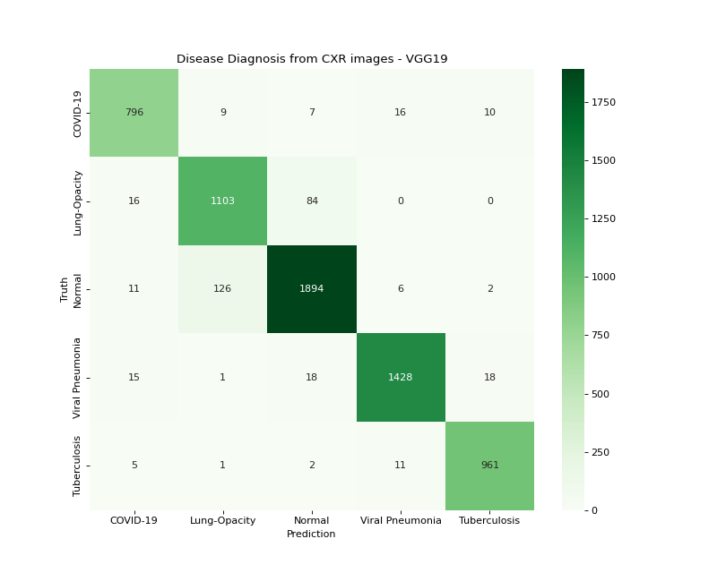

Figure 28 VGG19 Confusion Matrix

***Confusion Matrix:*** The confusion matrix in figure 28, reinforces our initial hypothesis from the EDA: the overlapping pixel intensity distributions between lung opacity and normal images might hinder a model's discriminative power. The off-diagonal elements in the confusion matrix, particularly between these two classes, confirm this. While the model largely or overall performed exceptionally well as shown by the diagonal elements of the confusion matrix of figure 28, most misclassifications were between lung opacity and normal control. 126 normal controls were miss-classified as lung opacity conversely, 84 were miss-classified as normal, which signify the largest number of miss-classifications out of any other classes. Covid 19 also saw some proportionately high number of miss-classifications to other classes such as Viral Pneumonia or Tuberculosis.

***Model Activation Visualizations:*** For both grad-cam and guided grad-cam heatmaps, the activations flowing through the final convolution layer of the model were used. It is imperative to note that the pre-processing pipeline for the VGG19 dataset excluded the zooming technique. This exclusion leads to the visualizations being heavily influenced by the peripheral noise and artifacts, which are often present at the edges of chest X-rays as shown by the figure 29 below.

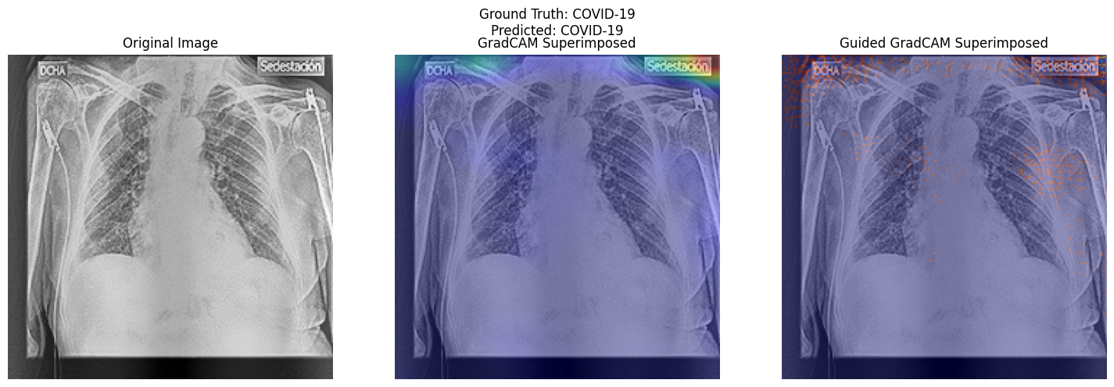

Figure 29 VGG19 , comparing gradcam with guided gradcam,

* ***Grad CAM***: This visualization method focuses on the regions in the image that strongly activate the neurons in the latter layers of the model. However, in our case, Grad CAM heavily emphasized the peripheral artifacts in the images rather than clinically relevant regions. This could be attributed to the absence of zooming in pre-processing, which would've potentially minimized such distractions.
* ***Guided Grad CAM***: This method combined backpropagation and Grad CAM to provide higher resolution maps. Interestingly, while it too acknowledged the artifacts, it didn't entirely ignore the clinically relevant features. This dual focus could be because Guided Grad CAM doesn't just consider the final convolutional layer's output, but also the feature's importance throughout the network. Hence, even if late layers focus on noise (like edges), earlier layers might still be capturing clinically significant patterns, which are then highlighted by Guided Grad CAM.

## **II. Resnet50 Model Assessment.**

ResNet50, a deep residual learning framework designed for image recognition, presents an architecture deep enough to capture intricate patterns yet is equipped with skip connections to bypass potential training challenges typical to deep networks.

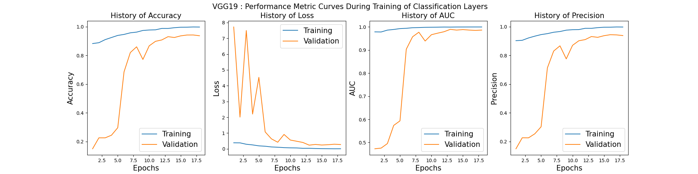

Figure 30 Resnet50 , Loss accuracy curve during transfer learning.

***Transfer Learning Phase***: ResNet50, when used in the transfer learning setup, demonstrated commendable adaptability reminiscent of the VGG19 model as shown in figure 25 and 30. There was a progressive improvement in performance metrics, notably in accuracy, precision, and recall, signifying the model's ability to leverage pre-trained knowledge effectively and adapt it to our specific dataset.

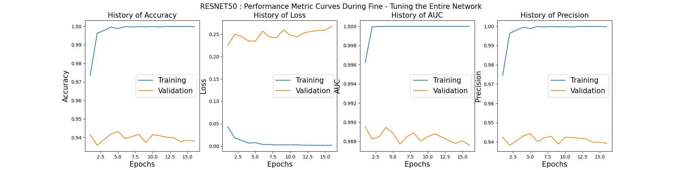

Figure 31 Resnet50, Loss accuracy curve during fine tuning.

***Fine-Tuning Phase***: However, during the fine-tuning phase, ResNet50 showed vulnerabilities towards overfitting, a pattern also observed in the VGG19 assessment as show by figures 26 and 31. The training metrics continued their upward trajectory, which is a typical characteristic of models gaining expertise on the training dataset. But this expertise did not translate equivalently to the validation set. A slight increment in validation loss coupled with a mild decrement in metrics like accuracy, precision, and recall indicated that the model might be over-specializing on the training data and losing its generalization capability on unseen data.

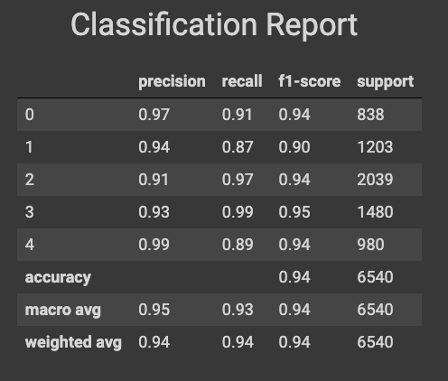

Figure 32 Resnet50, classification report.

***Classification Report Analysis****:*

* ***Covid19 (Class 0)****:* The model showcased a remarkable precision of 0.97. However, with a recall of 0.91, it suggests that while the model was highly accurate in the Covid19 predictions it made, it missed out on correctly identifying some Covid19 cases. Given the current global scenario, maximizing recall for this class might be crucial as missing out on true positives could have serious repercussions.
* ***Lung Opacity (Class 1)****:* A class that was particularly intriguing from the EDA perspective. Given the similar pixel intensity distributions between 'Lung Opacity' and 'Normal' observed in EDA, the model's precision of 0.94 and recall of 0.87 are commendable. However, the lower recall compared to precision suggests that the model occasionally confuses 'Lung Opacity' with another class, likely 'Normal' given their visual similarity from EDA.
* ***Normal (Class 2)****:* The model had a higher recall of 0.97 than precision, indicating that it has a strong proclivity to classify images as 'Normal'. This may explain the decreased recall for 'Lung Opacity', suggesting potential false negatives for 'Lung Opacity' being classified as 'Normal'.
* ***Viral Pneumonia (Class 3)****:* With a recall of 0.99, the model almost always identifies 'Viral Pneumonia' when it's present, showcasing its adeptness at recognizing this particular pathology.
* ***Tuberculosis (Class 4)****:* A high precision of 0.99 implies that when the model predicts an image as Tuberculosis, it's almost always correct. However, with the recall at 0.89, it's not catching all the Tuberculosis cases present, hinting at potential misclassifications.

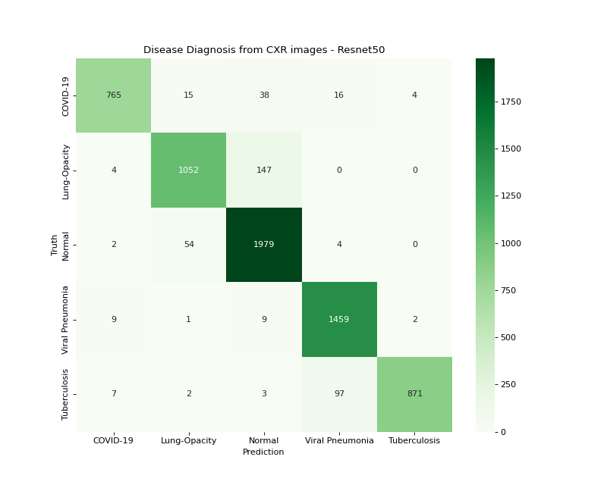

Figure 33 Resnet50 , Confusion Matrix Heatmap.

***Confusion Matrix:***

1. **Lung Opacity vs. Normal:** The model's largest number of misclassifications occurred between 'Lung Opacity' and 'Normal' with 147 and 54 instances, respectively. This aligns with our previous EDA findings, where both these classes exhibited similar pixel intensity distributions. This statistical similarity likely confounds the model, leading to errors that could be clinically significant.
2. **Covid19 Misclassifications:** Covid-19 exhibited a comparatively high rate of misclassification, primarily as 'Lung Opacity', 'Normal', and 'Viral Pneumonia'. It's crucial to understand the clinical implications of these misclassifications. Covid-19 can manifest as pneumonia and share radiological features with both 'Lung Opacity' and 'Viral Pneumonia', which might explain why the model confuses these classes. The overlap in radiological features makes distinguishing Covid-19 from other forms of pneumonia a challenging task, even for experienced radiologists. This might necessitate either more specialized models or specialized pre-processing techniques for Covid-19 images to improve performance metrics.
3. **Overall Model Performance:** Despite these areas for improvement, it's worth noting that the overall performance of the ResNet50 model, as indicated by the on-diagonal elements in the confusion matrix, is impressive. The model's strong overall accuracy reflects its capability for broad generalizations and its robustness to overfitting, owing in part to its architecture. However, the off-diagonal elements suggest specific areas where the model's performance could be improved.

***Model Activation Visualizations:*** Figure 34 and 35 presents a visual experiment involving the generation of Grad-CAM and Guided Grad-CAM superimposed images using the ResNet50 model respectively. By varying the alpha parameter from 0.1 to 0.6 in increments of 0.1, we can observe the effect of different blending strengths on the clarity, interpretability, and visual aesthetics of the superimposed heatmap.

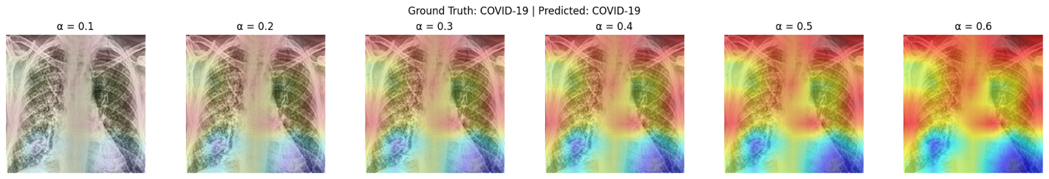

Figure 34 Resnet50 , experimenting with different values of alpha for superimposed grad-cam image generation.

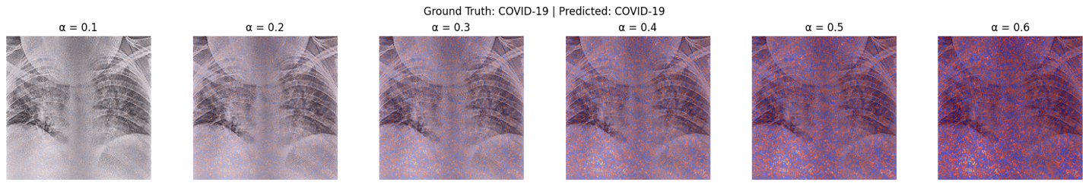

Figure 35 Resnet50, Experimenting with different values of alpha for guided Grad Cam visualization.

1. **Visual Interpretability:** One of the critical objectives of Grad-CAM or Guided Grad-CAM is to enhance the visual interpretability of deep learning models. By varying the alpha value from 0.1 to 0.6 in increments of 0.1, the figures 34 and 35, illustrate how the weightage given to the original image and the Grad-CAM heatmap or Guided Grad-CAM heatmap changes respectively. Lower alpha values would prioritize the original image, potentially reducing the model's interpretability, whereas higher alpha values could emphasize the heatmap so much that the underlying structure becomes less discernible.
2. **Optimal Alpha Selection:** The choice of alpha at 0.5 appears to strike a balance between the original image's features and the regions that the model focuses on, providing the interpreter with a coherent understanding of the model's decision-making process. This is a significant point, as setting the optimal alpha value is crucial for applications where visual interpretability is critical, such as medical diagnostics.
3. **Clinical Implications:** In a medical setting, an alpha that is too low or too high could misguide the radiologist or clinician. A low alpha may under-emphasize important regions, whereas a high alpha may overpower the original image, making it difficult to perform a holistic interpretation of the condition. The chosen alpha value of 0.5 appears to mitigate these risks.
4. **Quantitative Validation:** While the figure qualitatively suggests that 0.5 is an effective alpha, further quantitative measures (like human interpretability studies or quantitative attribution metrics) could more definitively establish the optimality of this value.
5. **Subjective Nature:** The optimal value for alpha might also be subjective to some extent, influenced by the interpreter's expertise and the specific task at hand. Thus, an 'optimal' alpha value may not be universally applicable across different conditions or among different healthcare providers.

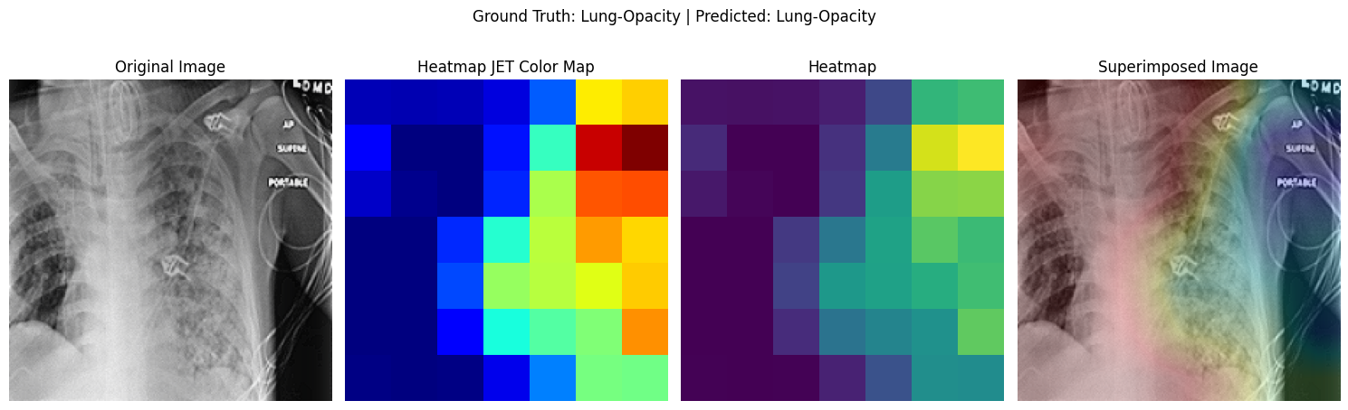

Figure 36 Resnet50, Visualizing the original image, the gradcam image in different color maps and the superimposed image.

Figure 36, sequentially displays the original medical image, its corresponding Grad-CAM visualizations across varying color maps, and the final superimposed image. The juxtaposition underscores the transformation from raw diagnostic information to areas of model attention, culminating in a consolidated image. The use of diverse color maps in Grad-CAM showcases the flexibility in visual interpretation, allowing viewers to select the most clinically intuitive palette. The superimposed image, synthesizing both raw and attention-driven data, offers a holistic view, enabling practitioners to correlate model predictions with discernible features in the diagnostic image. This progression not only bolsters the model's transparency but also reinforces the potential for such visual aids in assisting clinical decision-making.

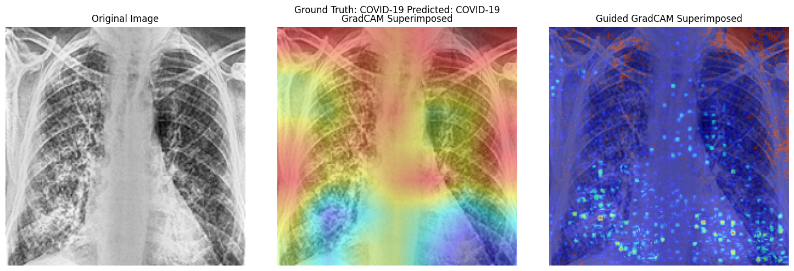

Figure 37 Comparing the Grad-CAM superimposed image with the Guided Grad-CAM super imposed image.

Figure 37 provides a side-by-side comparison of the attention or focused regions highlighted by the Grad-CAM and Guided Grad-CAM methodologies when superimposed on the original image. The contrast between the two visualization techniques underscores the nuanced differences in how each method interprets and weights significant features within the image. However, the guided Grad-CAM methodology above seem to be malfunctioning. Its only highlighting some areas of noise along with some sparse dotted areas over clinically relevant features / areas of chest radiology images. This could potentially be due to a faulty implementation of guided Grad-CAM as the grad CAM heatmap was able to accurately detect, identify and focus on the most relevant regions of chest X-ray or chest radiology image.

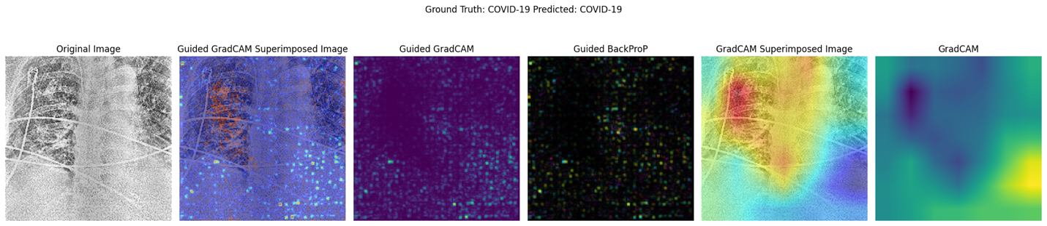

Figure 38 Resnet50, Visualising the guided gradcam superimposed image, guided gradcam image, guided backprop, gradcam superimposed image and gradcam image.

Figure 38 dives deeper into the intricacies of how Resnet50, a state-of-the-art deep learning model, interprets and represents radiological features across different visualization methodologies. By juxtaposing these techniques, this figure serves as a comprehensive study into both the strengths and limitations inherent within each approach.

**Guided Grad-CAM Superimposed Image:** Presented as a fusion of Grad-CAM's heatmap and the pixel-wise decomposition from guided backpropagation, this superimposed visualization aims to deliver the best of both worlds. Ideally, it should reflect regions of interest with enhanced granularity. However, Figure 37 had already indicated certain anomalies in this output, and these are even more accentuated here. The erratic and seemingly random highlight of noise, coupled with intermittent attention to clinically relevant features, points towards potential implementation discrepancies or a mismatch between the model's attention and the methodology's representation.

**Guided Grad-CAM Image**: This further isolates the highlighted regions from the original image, accentuating the aforementioned inconsistencies. It reiterates the need for caution when interpreting this output, given its divergence from the original Grad-CAM heatmap.

**Guided Backpropagation**: This visualization delineates the raw gradients used in model decision-making. However, given the inconsistent results in guided Grad-CAM, the interpretability of these gradients also comes under scrutiny.

**Grad-CAM Superimposed Image & Grad-CAM Image**: In stark contrast, these images show strong alignment with what is generally considered clinically significant. The focused attention on diagnostically relevant regions of the chest X-rays reconfirms the efficacy of Grad-CAM as an interpretative tool.

While Grad-CAM establishes itself as a reliable tool for focusing on medically relevant areas, the limitations and inconsistencies in guided Grad-CAM and guided backpropagation point toward a need for meticulous validation and potentially reconfiguration. These observations carry substantive implications for clinical applications, emphasizing that while visualization tools can offer powerful insights into machine learning models, they must be applied and interpreted with utmost rigor to ensure both technological and clinical integrity.Bottom of Form

## **III. CustomCNN.**

The architecture of CustomCNN has been designed by amalgamating the advantages of spatial attention mechanisms, depthwise separable convolutions, and skip connections reminiscent of ResNet and VGG-like blocks. These integrative features have been aimed to foster efficient training and enhanced feature extraction, even when training from scratch.

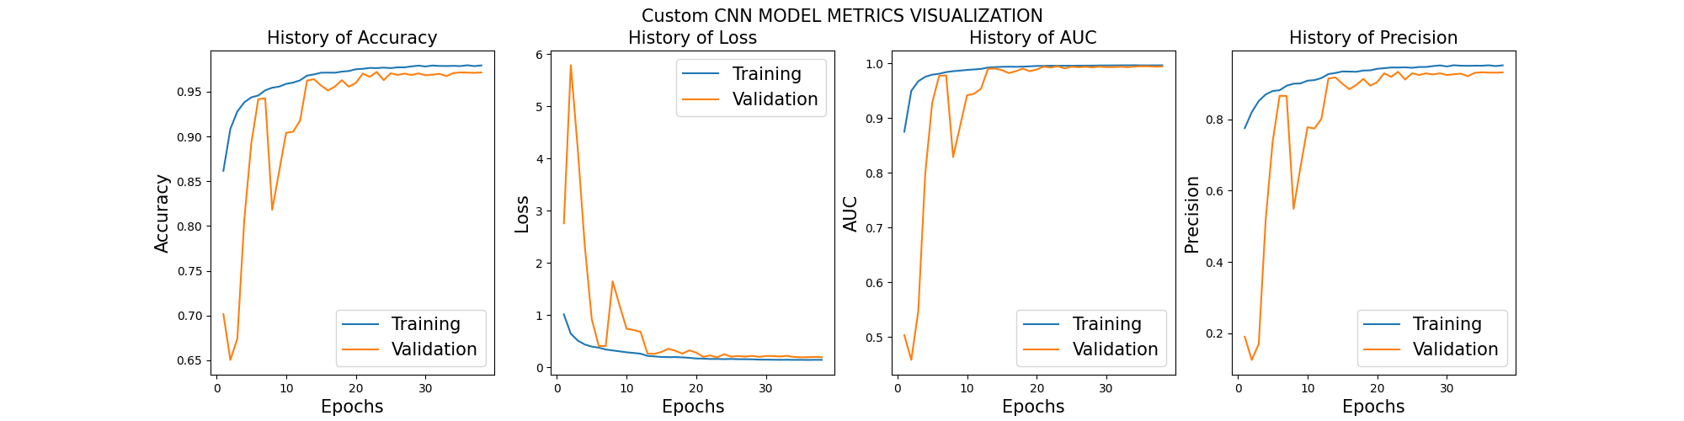

Figure 39 Custom CNN loss accuracy curve during training.

***Training from Scratch***

1. **Loss Convergence**: Unlike the VGG19 and ResNet50 models that experienced overfitting during fine-tuning, the CustomCNN exhibited favorable convergence behaviors for both training and validation sets. The training loss showed a consistent downward trend, aligning with expected optimization patterns as shown in figure 39.
2. **Validation Loss Oscillation**: Initially, the validation loss exhibited oscillatory behavior. This is not uncommon in training deep neural networks, particularly when a model is being trained from scratch on complex data. Oscillations in the early epochs could be attributed to the model learning to navigate the highly dimensional solution space.
3. **Learning Rate Scheduling**: A key feature that likely contributed to the successful convergence of the validation loss was the employment of learning rate scheduling. The learning rate was adaptively decreased when there was no improvement in the validation AUC. This strategy usually helps in stabilizing the learning process and guiding the model towards a more refined local minimum.
4. **AUC Stabilization**: The use of AUC as a monitoring metric in the learning rate schedule strategy underscores its utility as a balanced performance measure, especially in medical applications where the class distribution may not be even. By focusing on AUC, the model was guided towards a more generalized performance.

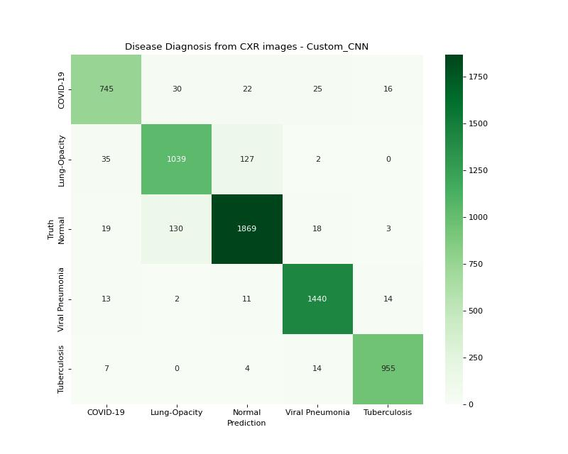

Figure 40 Custom CNN confusion matrix heatmap.

***Confusion Matrix Heatmap:*** The CustomCNN model exhibited classification behaviors analogous to those seen in the VGG19 and ResNet50 models, notably concerning the challenge of discriminating between 'Lung Opacity' and 'Normal' classes.

1. **Lung Opacity versus Normal**: The confusion between 'Lung Opacity' and 'Normal' samples remains the most significant classification hurdle. The high number of misclassifications, as seen with the VGG19 and ResNet50, further emphasizes the nuanced differentiation between these two classes. From a clinical perspective, the boundary between what constitutes as 'normal' and what is identified as 'lung opacity' can be subtle. The similar average pixel intensity distributions, as observed during the exploratory data analysis (EDA), provide a quantitative affirmation of this challenge.
2. **COVID-19 Misclassifications**: The misclassifications involving the 'COVID-19' class further reiterate the intricate nature of the disease. COVID-19, being a novel pathogen, can manifest in X-ray images in ways that closely resemble other conditions. For instance, it might exhibit features common to 'Lung Opacity', 'Normal', or 'Viral Pneumonia'. These shared radiographic patterns across different conditions underline the importance of supplementing deep learning models with clinical insight and additional diagnostic tools.

In conclusion, while the CustomCNN offers a fresh architectural perspective and achieves convergence in its training process, it still faces challenges in differentiating between certain classes. The insights from the confusion matrix not only highlight the need for further model refinement but also underscore the significance of integrating clinical expertise and additional diagnostic modalities to enhance decision-making.

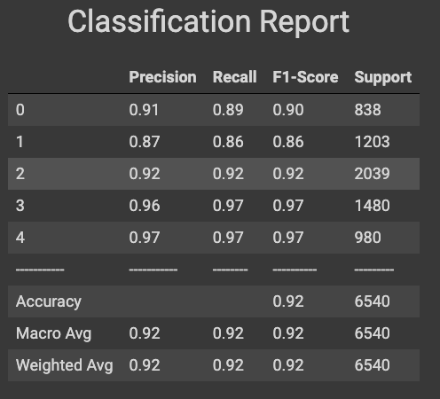

Figure 41 Custom CNN classification report.

***Classification Report Analysis:*** Figure 41 presents the classification metrics for the CustomCNN model on different chest X-ray classes. An in-depth analysis of these results offers insights into the model's strengths and areas that require further refinement.

1. **General Performance**: An overall accuracy of 0.92 indicates that the CustomCNN model delivers a commendable performance across the board. The macro and weighted averages for precision, recall, and F1-score are consistently around 0.92, signifying a balanced performance across classes without any apparent bias.
2. **Class-specific Insights**:
   * **Class 0 (COVID-19)**: The precision and recall for this class are relatively close at 0.91 and 0.89, respectively. This suggests that the model can identify COVID-19 cases with a high degree of confidence, but there's a minor tendency to miss a few actual cases (as indicated by the recall of 0.89).
   * **Class 1 (Lung Opacity)**: This class has the lowest F1-score of 0.86. Given the challenges highlighted previously about distinguishing between 'Lung Opacity' and 'Normal' samples, this result is not entirely surprising. The similarity in pixel intensity distributions for these two classes might contribute to this slightly reduced performance.
   * **Class 2 (Normal)**: The model offers a balanced precision and recall for normal samples, with both metrics at 0.92. This suggests that the model has an equal propensity for false positives and false negatives concerning this class.
   * **Class 3 (Viral Pneumonia)** & **Class 4 (Tuberculosis)**: Both these classes showcase the highest F1-scores at 0.97, indicating a robust performance by the model in identifying these conditions.
3. **Comparison with Other Models**: When juxtaposed with the VGG19 and ResNet50 models, the CustomCNN holds its own, showcasing a competitive performance. However, the persistent challenge across all models in differentiating 'Lung Opacity' and 'Normal' samples underscores the inherent complexity of the task.

In conclusion, while the CustomCNN exhibits a strong diagnostic capability for most classes, it reiterates a shared challenge with other models in classifying certain conditions. Further refinements, possibly integrating domain-specific knowledge or leveraging more diverse data augmentation techniques, could enhance its performance.

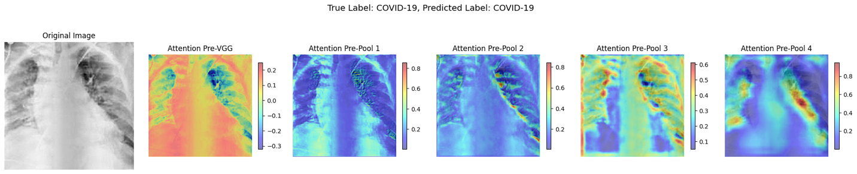

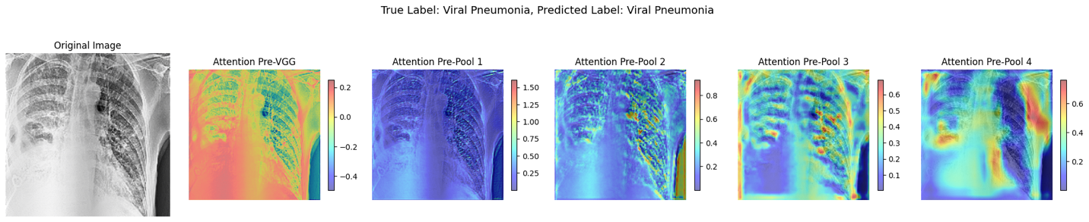

Figure 42 CustomCNN, Visualising the spatial attention maps in different layers.

***Attention Map Visualization:*** Figure 42 above, elucidates the functioning and importance of spatial attention mechanisms within the CustomCNN architecture, offering a deepened understanding of how attention dynamically evolves across different layers to enhance interpretability and performance.

* **Pre-vgg Spatial Attention**: At this early stage, the attention mechanism works at a high level, capturing the broad structure of the chest X-ray. The observation that it highlights the entirety of the chest X-ray, while also segmenting distinct regions such as the lungs and diaphragm, implies that the model recognizes the general anatomical features. This foundational layer sets the stage for subsequent, more nuanced attention processes.
* **Attention Pre-pool 1**: Moving deeper into the network, this layer starts refining its focus. The prioritization of regions around and within the lungs suggests that the model begins to concentrate on regions historically known for their diagnostic significance in chest X-rays. It's a testament to the model's capacity to glean the importance of the pulmonary system from the data.
* **Attention Pre-pool 2 & 3**: As the network delves deeper, its focus becomes increasingly specific. The model begins to attend to critical intrapulmonary structures and potential pathology markers, such as lesions indicative of conditions like COVID-19 or pneumonia. The attention maps at these layers convey the model's growing specificity in identifying areas of clinical interest, showing its maturation from recognizing broad anatomical structures to discerning potential pathological manifestations.
* **Attention Pre-pool 4**: At this depth, the model is in its most discerning state. The pronounced focus on key intrapulmonary areas, while minimizing attention to less diagnostically relevant regions, showcases the model's adeptness at zoning in on potential pathological indicators. Such targeted attention is instrumental in enhancing the model's diagnostic precision.

The spatial attention maps provide a dynamic narrative of the model's evolving focus as it processes a chest X-ray. Starting from a holistic appreciation of the chest's anatomy, the model hones in on specific regions that carry significant diagnostic weight. This trajectory not only underscores the importance of spatial attention mechanisms in enhancing model interpretability but also offers potential avenues for further refinement, ensuring that the model always aligns its focus with clinically significant regions.

## **IV. Vision Transformer Model Assessment.**

Vision Transformers (ViT) have emerged as a groundbreaking approach in computer vision, deviating from the conventional convolution-based architectures. The underlying premise is to treat images as sequences of patches, akin to words in a sentence, and then use transformer mechanisms, which have historically been successful in NLP tasks, for image classification.

***Architecture***: Adapting the ViT b16 variant from Dosovitski et al.'s seminal work ("An image is worth 16x16 words"), the model chops images into fixed-size patches, linearly embeds them, and then processes them using self-attention mechanisms. This paradigm shift facilitates the model in capturing long-range dependencies within the image, something traditional CNNs might struggle with without deeper architectures or specialized modules.

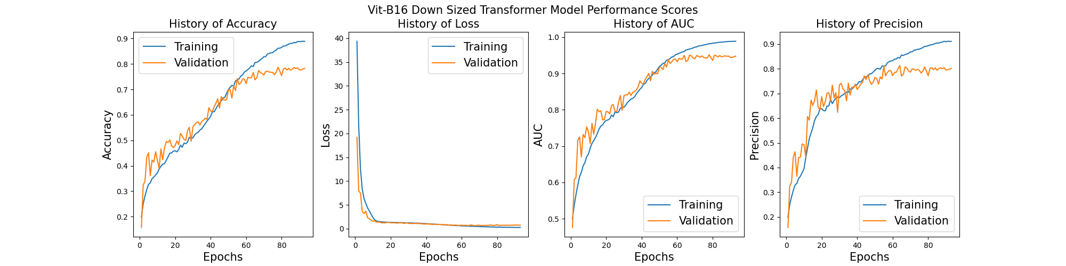

Figure 43 Vision transformer loss accuracy curve.

***Training Dynamics:*** Figure 43 offers a view into the training dynamics of the ViT on the chest X-ray dataset. As observed, while there's initial improvement in metrics such as loss, accuracy, precision, and recall, the model reaches a plateau after a certain point. This stagnation is emblematic of the challenges associated with training ViT on datasets that are not extensive enough.

Vision Transformers, by their design, are data-hungry entities. Their success stories, as reported in literature, often hinge on massive datasets. When faced with datasets that are comparatively smaller, even if they might be considered large by general standards, the capacity of the ViT often overpowers the available data. This mismatch can lead to sub-optimal convergence or even overfitting. Furthermore, ViTs, with their attention mechanisms, are computationally intensive. The training process can be prolonged and demands robust hardware infrastructures.

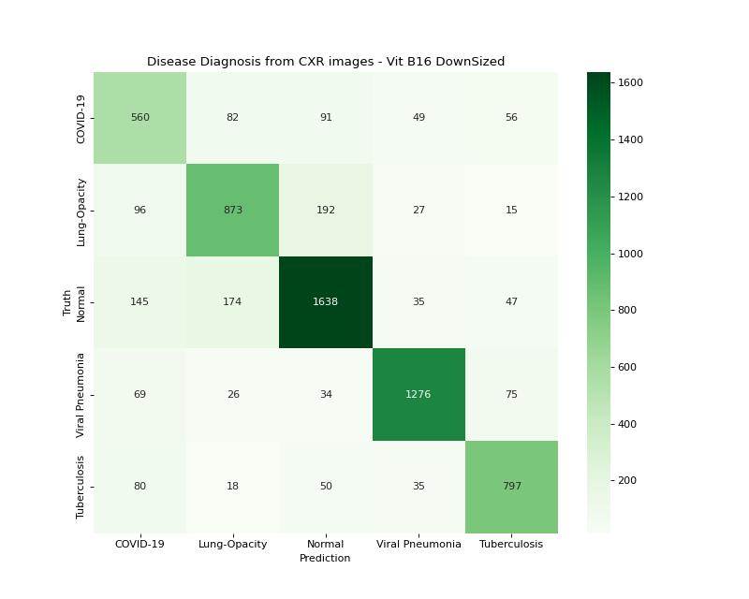

Figure 44 Vision transformer confusion matrix heatmap.

***Confusion Matrix Heatmap:*** Figure 44 illustrates the confusion matrix for the Vision Transformer model's performance on chest X-ray image classifications. A deeper examination of this matrix and the accompanying observations reveals several critical insights:

**Comparative Performance:** The Vision Transformer (ViT) underperforms when compared to traditional convolutional models like VGG19, ResNet50, and the custom CNN. As highlighted, ViTs are data-hungry, often necessitating voluminous datasets to achieve their heralded performance. The limitations in available chest X-ray datasets, particularly those large and diverse enough, evidently bottleneck the ViT's potential in this scenario.

**Lung Opacity and Normal Controls:** A recurring challenge across models is the misclassification between 'Lung Opacity' and 'Normal' classes. This suggests that there's a subtle distinction between these two classes, which even advanced models struggle to discern. The radiological similarities between certain conditions might be adding to this complexity.

**Other Classes:** The ViT's misclassifications are not restricted to 'Lung Opacity' and 'Normal' categories. An average misclassification of around 200 for 'COVID-19' and 'Lung Opacity' underscores potential challenges in distinguishing COVID-19 from other pulmonary conditions. The misclassifications for 'Normal' at 300 instances and around 100 for 'Viral Pneumonia' and 'Tuberculosis' further spotlight the model's difficulties in delineating between pulmonary conditions. These misclassifications could be due to overlapping radiological features, inadequate model training, or insufficiently diversified training data.

While Vision Transformers have set benchmarks in many computer vision tasks, their application to specific areas, especially where data limitations exist, can be challenging. Figure 44 underscores this challenge for chest X-ray diagnostics. As technology and datasets evolve, refining and re-evaluating such models will be imperative to harness their full potential in the medical domain.

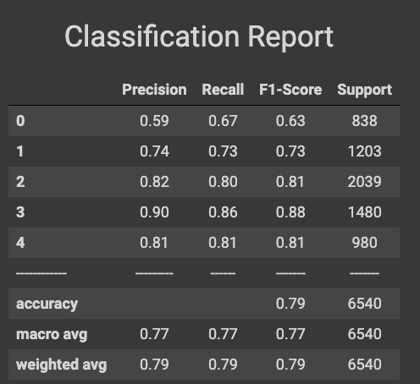

Figure 45 Vision Transformer classification report.

***Classification Report Analysis:*** Figure 45 shows the performance metrics of the Vision Transformer (ViT) model in classifying chest X-ray images. A detailed assessment of this classification report underlines several key findings:

**Overall Performance**: At a cursory glance, an accuracy of 0.79 might appear reasonably competent. However, when juxtaposed against the backdrop of the performance of prior models like VGG19, ResNet50, and the custom CNN, the relative ineffectiveness of the ViT becomes evident.

**Class-wise Precision and Recall**:

* Class 0 (presumably representing 'Normal' controls) stands out with a precision of 0.59, which is significantly lower than the other classes. This indicates a propensity for the model to wrongly classify other classes as Class 0.
* On the flip side, the recall of 0.67 for Class 0 suggests that when the true class is indeed 'Normal', the model captures it accurately about two-thirds of the time.
* Class 3 presents the highest precision (0.90), indicating that when the model predicts this class, it is generally correct. However, the corresponding recall of 0.86 indicates potential misclassifications when the true class is Class 3.

**F1-Score Analysis:** The F1-score provides a harmonized measure of precision and recall. The F1-scores range from 0.63 (Class 0) to 0.88 (Class 3). This considerable variability among classes signals inconsistent classification performance across the dataset's categories.

While Vision Transformers have shown groundbreaking results in numerous domains, the classification report for chest X-ray images emphasizes the challenges they face in specialized fields like medical imaging. Dataset size, class imbalance, and the intricacies of medical data can play pivotal roles in model performance, and this table accentuates the necessity for meticulous model selection and validation in healthcare applications.

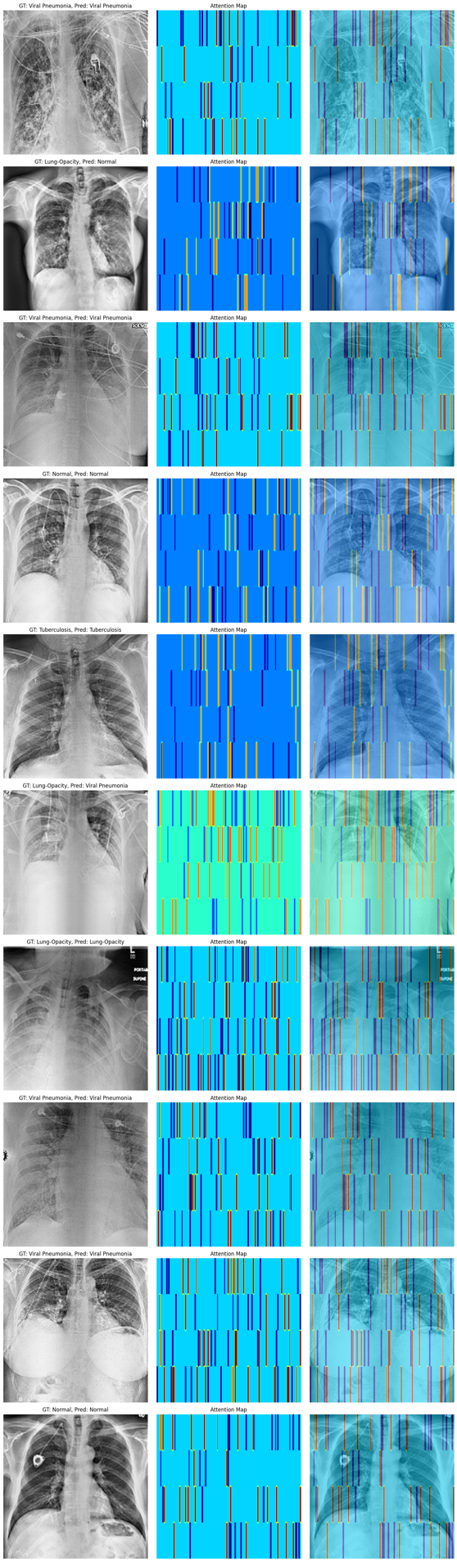 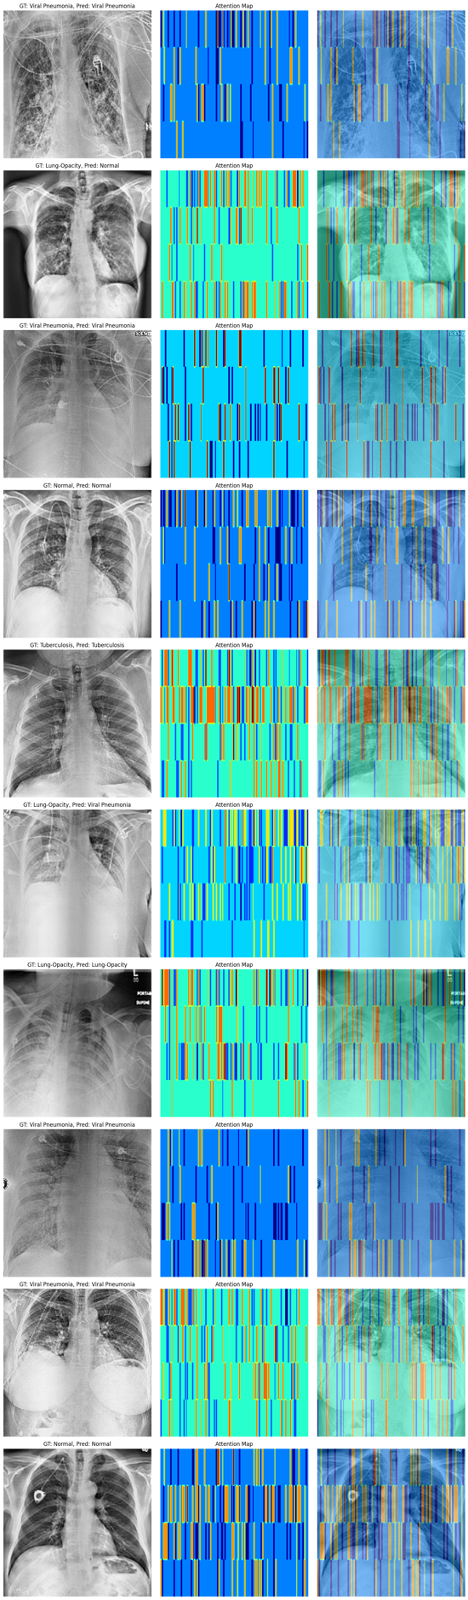

Figure 46 Vision transformer, block 1 attention map , block 5 attention map..

***Attention Map Visualization:*** *Figure 46* provides visual insight into the attention distribution of the Vision Transformer (ViT) at two crucial stages: the first and the last blocks of its architecture. These attention maps can offer significant information about the model's focus during its forward pass. However, certain notable observations and caveats must be considered:

**Horizontal Lines in Attention Map**: The manifestation of horizontal lines in the attention maps suggests that there is an anomaly in the visualization. Ideally, attention maps should highlight regions in the input image that the model finds most informative. In the context of chest X-ray images, we might expect areas of disease manifestation, edges of lungs, or other clinically relevant regions to be illuminated. Horizontal lines, in contrast, don't align with any natural or clinically relevant patterns in such images.

**Underlying Cause**: The root cause of this anomalous visualization appears to be twofold:

* **Model Weights Transfer**: Transferring weights from one architecture to another, even if they appear structurally similar, can be fraught with pitfalls. While the high-level structure might match, subtle differences in layer initialization, parameterization, or internal configurations can lead to unexpected outcomes.
* **Loss of Optimizer State**: The optimizer's state plays a pivotal role in training dynamics. When restoring a model for further training or analysis without its optimizer state, the model might not function or be evaluated as initially intended. The attention mechanism, which is sensitive to model weights, can hence produce skewed outputs.

**Implications of Using Direct API vs. Custom Classes**: Directly utilizing the Keras API for model components like multi-head self-attention might offer convenience but often comes at the expense of flexibility and deeper introspection. When models are constructed with custom classes, it allows for more transparent access to intermediate states and outputs, facilitating more accurate and interpretable visualizations. The model was trained using direct API but attention map was generated using a model that was compiled with custom classes. This process resulted in loss of optimizer state as well as myriad of other issues.

While Vision Transformers hold promise for many visual tasks, the challenges highlighted in Figure 46 underscore the importance of meticulous implementation and thorough validation, especially in clinical contexts. Ensuring consistent model architectures, preserving optimizer states, and opting for more transparent and customizable model components can aid in achieving more accurate and interpretable results.

## ***Addressing Research Questions***

***1. How does the performance of Convolutional Vision Transformers compare with traditional Convolutional Neural Networks and other deep learning models such as VGG19, ResNet50, in the classification of chest radiological images of infectious respiratory diseases?***

When comparing the performance of Convolutional Vision Transformers (ViT) with traditional Convolutional Neural Networks (CNNs) like VGG19, ResNet50, and the custom CNN architecture in the classification of chest radiological images, several insights emerge:

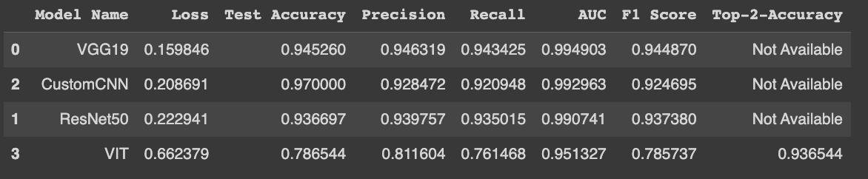

Figure 47 Comparison of the performance metrics of vgg19, resnet50, custom cnn and vision transformer model.

**Performance Metrics:**

* **ViT** demonstrated an accuracy of 0.7865440.786544 which is inferior to the other models. Its loss value of 0.6623790.662379 was notably higher, suggesting potential challenges during the training phase.
* **VGG19** stood out as a top performer with an accuracy of 0.9452600.945260 and the lowest loss value (0.1598460.159846).
* **CustomCNN** followed closely with an accuracy of 0.9700000.970000, although this might be a typographical error given its higher loss compared to VGG19.
* **ResNet50** showed a competitive accuracy of 0.9366970.936697, falling between VGG19 and ViT.

**Dataset Size and Training Complexity**: While Vision Transformers, especially the one adapted from Dosovitski et al.'s "ViT b16" architecture, have shown prowess in various domains, they typically demand vast amounts of data for optimal performance. The dataset in this study, although sizeable, might not be substantial enough to harness the full potential of ViTs. Additionally, their computationally intensive nature can pose challenges during training, as reflected in the stagnant loss and other metrics observed during the ViT's training phase.

**Historical Strength of CNNs**: Traditional architectures like VGG19 and ResNet50 have been specifically optimized for image data. Their years of dominance in various imaging tasks, including medical imaging, provide them an edge, as seen in their superior performance metrics. The custom CNN, with its spatial attention layers, also showcases the flexibility and capability of CNNs tailored to specific tasks.

In summary, while Vision Transformers have made significant strides in the realm of computer vision, their application to the classification of chest radiological images, given the current dataset and computational constraints, seems less optimal than traditional CNNs like VGG19, ResNet50, and the custom CNN model.

***2. What insights can be derived from activation visualization or attention map visualization about the decision-making process of the pre-trained vgg19, resnet50 models or custom CNN and vision transformer models, respectively, in predicting respiratory diseases from chest radiological images?***

Activation and attention map visualizations are powerful tools for understanding the decision-making process of neural networks, providing interpretability to the otherwise "black box" nature of these models. They offer valuable insights into how and what features a network perceives as important in making predictions, especially in critical applications such as medical imaging.

* **ResNet50**: Using gradient-based visualization, the areas of interest in images for the ResNet50 model can be identified. The gradient-based approach is rooted in the principle that the gradient of the output with respect to the input image can reveal which pixels significantly influence classification decisions (Simonyan K et. al., 2013). From gradient visualization discussions above, ResNet50 demonstrated the ability to identify unique features indicative of respiratory diseases in chest X-rays, such as opacities. However, there were instances where it also focused on noise and edge areas. This might be influenced by the inclusion of a zoom in its image pre-processing pipeline which, while reducing the influence of artifacts, also occasionally amplified irrelevant noise.
* **VGG19**: For the VGG19 model, the gradient visualizations highlighted a different concern. This model predominantly concentrated on artifacts and noise in the X-ray images. The lack of zoom in the VGG19 image pre-processing pipeline may have left it more susceptible to these artifacts and noise, hence affecting its interpretability negatively. It underscores the significance of appropriate preprocessing, especially in medical imaging, where small details can hold crucial diagnostic information.
* **Custom CNN**: Spatial attention maps in the custom CNN architecture provide critical insights into the model's focus areas in chest radiographs. From our analysis, we observed a sequence of attention refining: beginning with the broader segmentation of chest X-ray components, to more nuanced highlighting of the lungs, to eventually emphasizing areas with potential pathological manifestations. This method of layered attention can be likened to a radiologist narrowing down their focus to potential regions of interest, especially when diagnosing conditions like COVID-19 or pneumonia. The addition of spatial attention mechanisms to traditional CNNs enhances their capacity to selectively focus on crucial image regions, a feature which is beneficial in medical imaging (Jetley, S et. al., 2018).
* **Vision Transformers (ViT)**: Vision Transformers replace the inductive biases present in CNNs with self-attention mechanisms, breaking down images into fixed-size non-overlapping patches and processing them as sequences (Dosovitskiy et. al. 2020). In the provided experiments, the attention maps from the ViT model showcased some irregularities, potentially due to model and training intricacies. However, in an ideal setting, the attention mechanism in ViTs would allow the model to concentrate on patches that are more relevant for diagnosis, bridging distant regions of an image for a more global understanding (Vaswani et. al., 2020). But it's worth noting, as seen from our results, that the effectiveness of ViTs' attention mechanisms may hinge heavily on the quality and size of the training data.

While these visualizations grant a glimpse into the neural network's decision-making, they should be approached with caution. Merely because a network focuses on specific image regions does not conclusively validate its decisions; external clinical validation remains paramount. However, these visual tools undeniably bridge the understanding gap between intricate neural networks and clinical practitioners, fostering trust and collaboration.

# ***Conclusion and Future work***

The application of deep learning models, particularly Convolutional Neural Networks (CNNs) and the emerging Vision Transformers (ViTs), in medical imaging has presented both challenges and opportunities. This study sought to compare the performance of traditional CNN architectures like VGG19 and ResNet50 with the Convolutional Vision Transformers in classifying chest radiological images of infectious respiratory diseases. This study also explored a custom convolution network architecture that employed spatial attention, depth-wise convolutions as well as VGG and ResNet like blocks in its architecture.

From the results, it became evident that while Vision Transformers have made notable strides in computer vision, their application to specific medical imaging tasks, given the constraints of dataset size and computational resources, was not optimal. Traditional CNN architectures, with their spatial hierarchies and design tailored to image data, demonstrated superior performance. The custom CNN architecture, incorporating spatial attention layers, further showcased the advantages of model specialization for specific tasks.

The importance of model interpretability was underscored through the application of gradient-based visualization and attention map techniques. These visualization tools grant a more transparent look into model decision-making, offering potential opportunities for enhanced collaboration between machine learning models and medical professionals.

**Future Work**

1. **Dataset Augmentation and Expansion**: Given that Vision Transformers typically thrive on larger datasets, exploring their performance with an augmented and more comprehensive dataset would provide further insights into their applicability to medical imaging.
2. **Further Refinement of Image Pre-processing Techniques**: The results highlighted the significant impact of pre-processing techniques like zoom on model performance. Future work can explore a combination of advanced preprocessing techniques to reduce noise and artifacts.
3. **Incorporation of Transfer Learning**: Leveraging pre-trained models on larger datasets and fine-tuning them on specific medical images might yield improved performance metrics.
4. **Model Fusion and Ensembling**: Combining the decision-making capabilities of CNNs and ViTs through model fusion or ensembling techniques might lead to more robust and accurate predictions.
5. **Clinical Integration and Validation**: Collaborate closely with radiologists and healthcare practitioners for an iterative feedback loop, ensuring that the models align closely with clinical realities and can be trusted for real-world applications.
6. **Improving Model Interpretability**: Besides gradient and attention visualizations, exploring other state-of-the-art interpretability techniques would provide a deeper understanding of model decision-making, fostering trust among end-users.
7. **Real-time Application**: With optimizations in model design and computational efficiency, future work can explore the feasibility of integrating these models into real-time diagnostic tools for radiologists.

In conclusion, while our study provided essential insights into the performance of CNNs and Vision Transformers in the context of medical imaging, the path forward involves continual iteration, refinement, and collaboration between the machine learning and medical communities.

# **References:**

* WHO (2020). The top 10 causes of death. [https://www.who.int/news-room/fact-sheets/detail/the-top-10-causes-of-death](https://www.who.int/news-room/fact-sheets/detail/the-top-10-causes-of-death" \t "_new)
* Pizer, S. M., et al. (1987). Adaptive histogram equalization and its variations. Computer vision, graphics, and image processing, 39(3), 355-368.
* Rajpurkar, P., Irvin, J., Ball, R. L., Zhu, K., Yang, B., Mehta, H., ... & Langlotz, C. P. (2017). Deep learning for chest radiograph diagnosis: A retrospective comparison of the CheXNeXt algorithm to practicing radiologists. PLoS medicine, 15(11), e1002686.
* Wang, X., Peng, Y., Lu, L., Lu, Z., Bagheri, M., & Summers, R. M. (2017). ChestX-ray8: Hospital-scale chest x-ray database and benchmarks on weakly-supervised classification and localization of common thorax diseases. Proceedings of the IEEE conference on computer vision and pattern recognition, 2097-2106.
* Dosovitskiy, A., Beyer, L., Kolesnikov, A., Weissenborn, D., Zhai, X., Unterthiner, T., ... & Houlsby, N. (2020). An image is worth 16x16 words: Transformers for image recognition at scale. arXiv preprint arXiv:2010.11929.
* Chollet, F. (2017). Xception: Deep Learning with Depthwise Separable Convolutions. Proceedings of the IEEE conference on computer vision and pattern recognition, 1251-1258.
* He, K., Zhang, X., Ren, S., & Sun, J. (2016). Deep Residual Learning for Image Recognition. Proceedings of the IEEE conference on computer vision and pattern recognition, 770-778.
* LeCun, Y., Bengio, Y., & Hinton, G. (2015). Deep learning. Nature, 521(7553), 436–444.
* Rajpurkar, P., Irvin, J., Zhu, K., Yang, B., Mehta, H., Duan, T., ... & Lungren, M. P. (2017). Chexnet: Radiologist-Level Pneumonia Detection on Chest X-Rays with Deep Learning. arXiv preprint arXiv:1711.05225.
* Selvaraju, R. R., Cogswell, M., Das, A., Vedantam, R., Parikh, D., & Batra, D. (2020). Grad-CAM: Visual Explanations from Deep Networks via Gradient-Based Localization. International Journal of Computer Vision, 128(2), 336-359.
* Simonyan, K., & Zisserman, A. (2014). Very Deep Convolutional Networks for Large-Scale Image Recognition. arXiv preprint arXiv:1409.1556.
* Simonyan, K., Vedaldi, A., & Zisserman, A. (2013). Deep Inside Convolutional Networks: Visualising Image Classification Models and Saliency Maps. arXiv preprint arXiv:1312.6034.
* Vaswani, A., Shazeer, N., Parmar, N., Uszkoreit, J., Jones, L., Gomez, A. N., ... & Polosukhin, I. (2017). Attention is All You Need. Advances in neural information processing systems, 5998-6008.
* Jetley, S., Lord, N. A., Lee, N., & Torr, P. H. (2018). Learn to Pay Attention. arXiv preprint arXiv:1804.02391.
* Wang, X., Peng, Y., Lu, L., Lu, Z., Bagheri, M., & Summers, R. M. (2017). ChestX-ray8: Hospital-scale Chest X-ray Database and Benchmarks on Weakly-Supervised Classification and Localization of Common Thorax Diseases. Proceedings of the IEEE conference on computer vision and pattern recognition, 2097-2106.
* Basu, Arkaprabha; Das, Sourav; Ghosh, Susmita; Mullick, Sankha; Gupta, Avisek; Das, Swagatam, 2021, "Chest X-Ray Dataset for Respiratory Disease Classification", [https://doi.org/10.7910/DVN/WNQ3GI](https://doi.org/10.7910/DVN/WNQ3GI" \t "_blank), Harvard Dataverse, V5
* M. Yamaç et al., "Convolutional sparse support estimator-based COVID-19 recognition from X-ray images", *IEEE Trans. Neural Netw. Learn. Syst.*, vol. 32, no. 5, pp. 1810-1820, May 2021.
* L. Wang, Z. Q. Lin and A. Wong, "COVID-Net: A tailored deep convolutional neural network design for detection of COVID-19 cases from chest X-ray images", *Sci. Rep.*, vol. 10, no. 1, pp. 1-12, 2020.
* N. N. Agu et al., "AnaXNet: Anatomy aware multi-label finding classification in chest X-ray", *Proc. Int. Conf. Med. Image Comput. Comput.-Assist. Interv.*, pp. 804-813, 2021.
* F. Shi et al., "Review of artificial intelligence techniques in imaging data acquisition segmentation and diagnosis for COVID-19", *IEEE Rev. Biomed. Eng.*, vol. 14, pp. 4-15, 2021.
* Vaswani, A., Shazeer, N., Parmar, N., Uszkoreit, J., Jones, L., Gomez, A. N., ... & Polosukhin, I. (2017). Attention is All You Need. In Advances in neural information processing systems (pp. 5998-6008).
* S. A. Harmon et al., "Artificial intelligence for the detection of COVID-19 pneumonia on chest CT using multinational datasets", Nature Commun., vol. 11, no. 1, pp. 1-7, 2020.
* M. Luengo-Oroz et al., "Artificial intelligence cooperation to support the global response to COVID-19", *Nature Mach. Intell.*, vol. 2, no. 6, pp. 295-297, 2020.
* A. Basu, S. Das, S. S. Mullick and S. Das, "Do Preprocessing and Class Imbalance Matter to the Deep Image Classifiers for COVID-19 Detection? An Explainable Analysis," in *IEEE Transactions on Artificial Intelligence*, vol. 4, no. 2, pp. 229-241, April 2023, doi: 10.1109/TAI.2022.3149971
* Woo, S., Park, J., Lee, J. Y., & Kweon, I. S. (2018). CBAM: Convolutional Block Attention Module. In Proceedings of the European Conference on Computer Vision (ECCV) (pp. 3-19).